|  |
| --- |
| Project: NMK NCTS5  Trader Specs - Message Exchanges  EUROPEAN DYNAMICS  **November 2024** |

**Document History**

|  |  |  |  |
| --- | --- | --- | --- |
| **Version / Date** | **Author** | **Description** | **Action** |
| V1.00 – 20/01/2023 | ED | Initial Draft | C |
| V1.10 – 12/04/2023 | ED | Alignment with DDNTA v5.15.1 | U |
| V1.20 – 20/09/2024 | ED | Added flow for Control at Destination | U |
| V2.00 | ED | Alignment with DDNTA v5.15.2 | U |

**Reviews**

|  |  |  |  |
| --- | --- | --- | --- |
| **Version / Date** | **Author** | **Description** | **Action** |
|  |  |  |  |

**Reference Documents**

| Ref. | Title | Reference | Version | Date |
| --- | --- | --- | --- | --- |
| R01 | NCTS Phase 5 - Design Document for National Transit Application | DDNTA | 5.15.1-v1.00 | 07/03/2023 |
| R02 | NCTS Phase 5 - Design Document for National Transit Application | DDNTA | 5.15.2-v2.00 | 01/12/2023 |

**Table of Contents**

1 Introduction 10

1.1 Purpose 10

1.2 Intended Audience 11

1.3 Related documents 11

1.4 Notation 12

2 Datasets 13

3 Functional Areas 16

3.1 Core Flow (CFL) 16

3.1.1 Standard Transit Procedure (overview) 16

3.2 Specific Scenarios at Office of Departure (DEP) 28

3.2.1 Declaration Lodged Prior to Presentation of Goods 28

3.2.2 Amendment of Transit Declaration 45

3.2.3 Invalidation of Transit Declaration 48

3.3 Specific Scenarios at Office of Destination (DES) 56

3.3.1 State Diagrams at Office of Destination 56

3.3.2 Simplified procedure at destination 57

3.3.3 Manual closure at Departure based on alternative proof 61

3.3.4 Diversion at Office of Destination 62

3.4 Specific Scenarios for Incidents “En Route” (INC) 63

3.4.1 Sequence Diagram 63

3.4.2 State Diagram 64

3.4.3 Use Case Summary 64

3.5 Possible Exceptions in the Common Domain (EXC) 65

3.5.1 Deviation from the Binding Itinerary at Actual Office of Transit - Movement is allowed Diversion after registering the Incident 65

3.6 Export Followed by Transit (EFT) 66

3.6.2 Export followed by transit - External transit 69

3.6.3 Export followed by transit - Internal transit 76

3.6.4 Amendment of transit declaration having export as previous procedure 81

3.6.5 Transit movement having export as previous procedure - Control results from destination indicate major discrepancies 85

3.6.6 Transit movement having export as previous procedure - Departure notifies Office of Exit for the initiation of Recovery 88

3.6.7 Manual closure at Departure based on alternative proof - Export is previous procedure 89

3.6.8 Invalidation of transit declaration having export as previous procedure - Before release for transit 91

3.7 NCTS GUARANTEE MANAGEMENT (GMN) 93

3.7.1 Guarantee Access Codes 94

3.7.2 Guarantee Update Notification 94

3.7.3 Comprehensive Guarantee Cancellation Notification 94

3.7.4 Check Guarantee Integrity (GUI) 95

3.7.5 Guarantor message exchanges 96

3.8 NCTS HANDLE ENQUIRY & RECOVERY 97

3.8.1 Enquiry 97

3.8.2 Recovery 99

3.9 Controls 101

3.9.1 Controls at Office of Departure 101

3.9.2 Message Exchange when Control Case is open 106

**Table of Figures**

Figure 1: Standard Transit Procedure (overview) - Sequence Diagram 17

Figure 2: Release of a Guarantee after resolution of major discrepancies in the destination control results - Sequence Diagram 18

Figure 3: Standard Transit Procedure at Departure - State Diagram 19

Figure 4: Transit presentation notification - Sequence Diagram 30

Figure 5: Transit presentation notification - State Diagram 31

Figure 6: Correction of the pre-lodged declaration - Sequence Diagram 35

Figure 7: Correction of the pre-lodged declaration - State Diagram 36

Figure 8: Cancellation of the pre-lodged declaration prior to presentation of goods - Sequence Diagram 39

Figure 9: Cancellation of the pre-lodged declaration prior to presentation of goods - State Diagram 40

Figure 10: Simplified procedure at Departure - Sequence Diagram 42

Figure 11: Simplified procedure at Departure - State Diagram 43

Figure 12: Amendment of Transit Declaration - Sequence Diagram 46

Figure 13: Amendment of Transit Declaration - State Diagram 47

Figure 14: Invalidation request before release for transit - Sequence Diagram 49

Figure 15: Invalidation request before release for transit - State Diagram 50

Figure 16: Invalidation request by the Holder of the Transit Procedure after release for transit - Sequence Diagram 53

Figure 17: Invalidation request by the Holder of the Transit Procedure after release for transit - State Diagram 54

Figure 18: Invalidation of a transit declaration after release for transit - Sequence Diagram 55

Figure 19: Invalidation of a transit declaration after release for transit - State Diagram 56

Figure 20: Transit Procedure at Office of Destination - State Diagram 57

Figure 21: Simplified Procedure at destination - Sequence Diagram 58

Figure 22: Manual closure at Departure based on alternative proof - Sequence Diagram 62

Figure 23: Manual closure at Departure based on alternative proof - State Diagram 62

Figure 24: Diversion at Office of Destination - Sequence Diagram 63

Figure 25: Incidents En Route - Capturing Movement Information - Sequence Diagram 64

Figure 26: Incidents En Route - Capturing Movement Information - State Diagram 65

Figure 27: Deviation from Binding Itinerary at Actual Office of Transit - Sequence Diagram 66

Figure 28: Deviation from Binding Itinerary at Actual Office of Transit - State Diagram 66

Figure 29: Export followed by Transit Office of Departure - State Diagram 68

Figure 30: Export followed by Transit Office of Destination - State Diagram 69

Figure 31: Export followed by Transit - External Transit - Sequence Diagram 70

Figure 32: Export followed by Transit - Internal Transit - Sequence Diagram 77

Figure 33: Amendment of transit declaration having export as previous procedure - Sequence Diagram 82

Figure 34: Control results from destination indicate major discrepancies - Sequence Diagram 86

Figure 35: Control results from destination indicate major discrepancies - State Diagram 87

Figure 36: Initiation of Recovery of transit declaration having export as previous procedure - Sequence Diagram 89

Figure 37: Initiation of Recovery of transit declaration having export as previous procedure - State Diagram 89

Figure 38: Closure based on alternative proof - Sequence Diagram 90

Figure 39: Closure based on alternative proof - State Diagram 91

Figure 40: Invalidation of transit declaration having export as previous procedure - Sequence Diagram 92

Figure 41: Invalidation of transit declaration having export as previous procedure - State Diagram 93

Figure 42: Information exchange for Guarantee management - Overview 94

Figure 43: Check guarantee integrity - Sequence Diagram 96

Figure 44: Check guarantee integrity - State Diagram 96

Figure 45: Information Exchange involving the Guarantor 97

Figure 45: Enquiry - Sequence Diagram 98

Figure 46: Enquiry - State Diagram 99

Figure 47: Recovery - Sequence Diagram 100

Figure 48: Recovery - State Diagram 101

Figure 49: Controls at Office of Departure - Sequence Diagram 102

**Table of Tables**

Table 1: Abbreviations and Acronyms 10

Table 2: List of related documents 12

Table 3: State Diagrams Notation 13

Table 4: Exchanged Messages 16

Table 4: Message exchange during controls 107

**Abbreviations and Acronyms**

| Abbreviation | Meaning |
| --- | --- |
| AIS | Automated Import System |
| AN | Arrival Notification |
| BR | Business Rule |
| CA | Contracting Authority |
| CD | Customs Declaration |
| CM | Case Management |
| CSW-CERTEX | Customs Single Window – Certificates Exchange |
| C&E | Customs and Excise Department |
| ED | European Dynamics SA |
| EIDR | Entry in Declarant’s Records |
| EMCS | Excise Movement and Control System |
| EORI | Economic Operator Registration and Identification |
| MRN | Movement Reference Number |
| NID | National Import Declaration |
| IT | Information Technology |
| PN | Presentation Notification |
| RA | Risk Analysis |
| RMS | Risk Management System |
| SP | Special Procedures |
| TS | Temporary Storage |
| TSD | Temporary Storage Declaration |
| T2L(F) | Customs document for the confirmation of Union status |
| UCC | Union Customs Code |

Table 1: Abbreviations and Acronyms

# Introduction

## Purpose

The purpose of this document is to describe the information (messages) **Traders**[1] will be exchanging with the NCTS P5 application (NCTSP5 hereafter).

This document is divided into the following functional areas:

* Core Flow (CFL)
* Specific Scenarios at Office of Departure (DEP)
* Specific Scenarios at Office of Destination (DES)
* Specific Scenarios for Incidents ‘En-Route’ (INC)
* Possible Exceptions in the Common Domain (EXC)
* Export Followed by Transit (EFT)
* NCTS Guarantee Management (GMN)
* NCTS Handle Enquiry & Recovery
* Controls

For each functional area, the document contains:

* Sequence Diagrams describing the messages exchanged between Traders and the Customs at a logical level, this excludes technical details.
* Declaration state transition diagrams. Where possible, state transition diagrams have been included that show all possible states that a declaration can acquire during processing and the action/messages that cause the transition.
* Summary Use Cases that describe the possible flows.

## Intended Audience

The present document is intended to be read by the following people:

* MK Project Management Team
* MK Customs Experts
* ED Project Management Team
* ED IT Development Team
* Trader IT Development Teams

## Related documents

This document should be read in conjunction with the following documents:

|  |  |
| --- | --- |
| **Document name** | **Description** |
| Message Structures | Contains the logical structure of all messages exchanged between traders and the NCTSP5 |
| Codelists | Contains all codelists referred to within the message-structures document |
| Business Rules and Conditions | Contains all business rules and conditions referred to within the message-structures document and applied during message validation |
| XSDs | Contains all message XSDs describing the business message content in XML |

Table 2: List of related documents

## Notation

**State Diagrams**

|  |  |  |
| --- | --- | --- |
| **Symbol** | **Meaning** | **Example** |
| . | Used to notify two consecutive messages sent by one sender | **TR562. TR862**  Both TR562 and TR862 are sent, in that order, by the same sender without receiving a response in between. The time elapsed in between depends on the scenario. |
| ^ | Used to notify a response to a previous message or event | **Controls ^ IE060**  Controls will be performed, therefore IE060 is sent |
| , | Can be substituted with OR | **TR562, IE013, IE004**  Either of these messages will have the same impact in terms of movement state |

Table 3: State Diagrams Notation

# Datasets

The following table contains a list of all the messages exchanged between Traders and Customs for NCTS.

| **IE** | **Root Element** | **Message Name** | **Sent by** |
| --- | --- | --- | --- |
| IE004 | CC004C | AMENDMENT ACCEPTANCE | Customs |
| IE007 | CC007C | ARRIVAL NOTIFICATION | Trader |
| IE009 | CC009C | INVALIDATION DECISION | Customs |
| IE013 | CC013C | DECLARATION AMENDMENT | Trader |
| IE014 | CC014C | DECLARATION INVALIDATION REQUEST | Trader |
| IE015 | CC015C | DECLARATION DATA | Trader |
| IE019 | CC019C | DISCREPANCIES | Customs |
| IE022 | CC022C | NOTIFICATION TO AMEND DECLARATION | Customs |
| IE023 | CC023C | GUARANTOR NOTIFICATION | Customs |
| IE025 | CC025C | GOODS RELEASE NOTIFICATION | Customs |
| IE026 | CC026C | GUARANTEE ACCESS CODES | Trader |
| IE028 | CC028C | MRN ALLOCATED | Customs |
| IE029 | CC029C | RELEASE FOR TRANSIT | Customs |
| IE034 | CC034C | QUERY ON GUARANTEES | Trader |
| IE035 | CC035C | RECOVERY NOTIFICATION | Customs |
| IE037 | CC037C | RESPONSE QUERY ON GUARANTEES | Customs |
| IE043 | CC043C | UNLOADING PERMISSION | Customs |
| IE044 | CC044C | UNLOADING REMARKS | Trader |
| IE045 | CC045C | WRITE-OFF NOTIFICATION | Customs |
| IE051 | CC051C | NO RELEASE FOR TRANSIT | Customs |
| IE054 | CC054C | REQUEST OF RELEASE | Trader |
| IE055 | CC055C | GUARANTEE NOT VALID | Customs |
| IE056 | CC056C | REJECTION FROM OFFICE OF DEPARTURE | Customs |
| IE057 | CC057C | REJECTION FROM OFFICE OF DESTINATION | Customs |
| IE060 | CC060C | CONTROL DECISION NOTIFICATION | Customs |
| IE140 | CC140C | REQUEST ON NON-ARRIVED MOVEMENT | Customs |
| IE141 | CC141C | INFORMATION ABOUT NON-ARRIVED MOVEMENT | Trader |
| IE170 | CC170C | PRESENTATION NOTIFICATION FOR THE PRE-LODGED DECLARATION | Trader |
| IE182 | CC182C | FORWARDED INCIDENT NOTIFICATION TO ED | Customs |
| IE224 | CC224C | INDIVIDUAL GUARANTEE VOUCHER SOLD | Trader |
| IE225 | CC225C | GUARANTEE UPDATE NOTIFICATION | Customs |
| IE228 | CC228C | COMPREHENSIVE GUARANTEE CANCELLATION LIABILITY LIBERATION | Customs |
| IE229 | CC229C | INDIVIDUAL GUARANTEE VOUCHER REVOCATION NOTIFICATION | Customs |
| IE231 | CC231C | COMPREHENSIVE GUARANTEE CANCELLATION NOTIFICATION | Customs |
| IE906 | CC906C | FUNCTIONAL NACK | Customs |
| IE917 | CC917C | XML NACK | Customs |
| IE928 | CC928C | POSITIVE ACKNOWLEDGE | Customs |
| TR015V | TR015V | Transit Pre-lodged Declaration Acknowledgment | Customs |
| TR054 | TR054 | Request for Advice | Customs |
| TR062 | TR062 | Request Declaration Amendment | Customs |
| TR862 | TR862 | Declaration Amendment Request Cancellation | Customs |
| TR064 | TR064 | Request Declaration Invalidation | Customs |
| TR864 | TR864 | Declaration Invalidation Request Cancellation | Customs |
| TR082 | TR082 | Documents Request | Customs |
| TR083 | TR083 | Documents Received | Customs |
| TR084 | TR084 | Request Document Presentation | Customs |
| TR882 | TR882 | Documents Upload Request Cancellation | Customs |
| TR884 | TR884 | Documents Presentation Request Cancellation | Customs |

Table 4: Exchanged Messages

The required data elements for each dataset, the structure of the data elements within each dataset, as well as the business rules that apply on them can be found in the “NCTS-Message-Structures” document.

# Functional Areas

## Core Flow (CFL)

### Standard Transit Procedure (overview)

#### Sequence Diagram

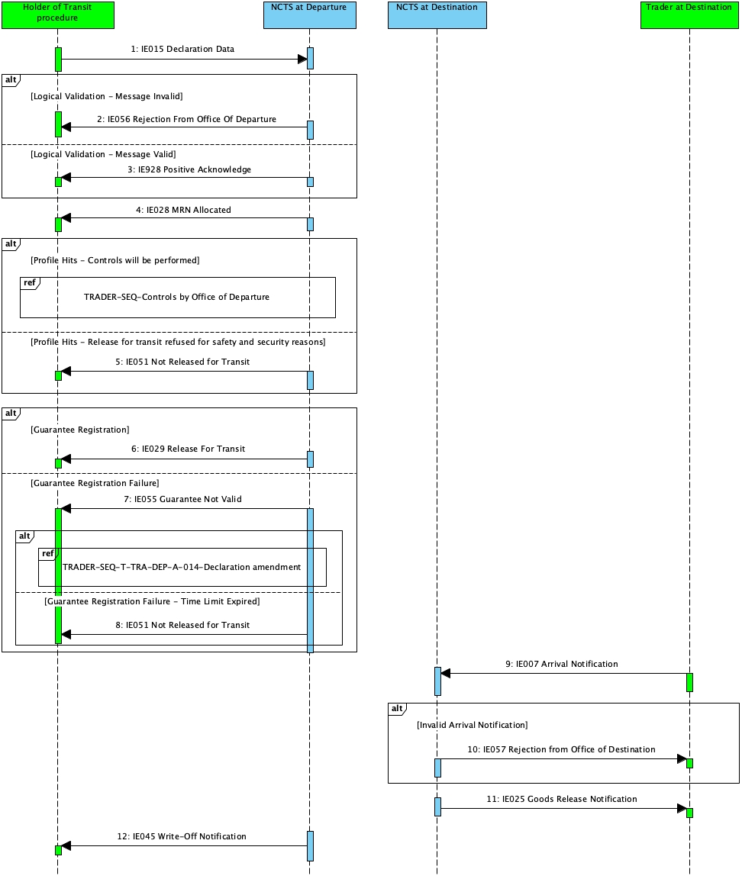

Figure 1: Standard Transit Procedure (overview) - Sequence Diagram

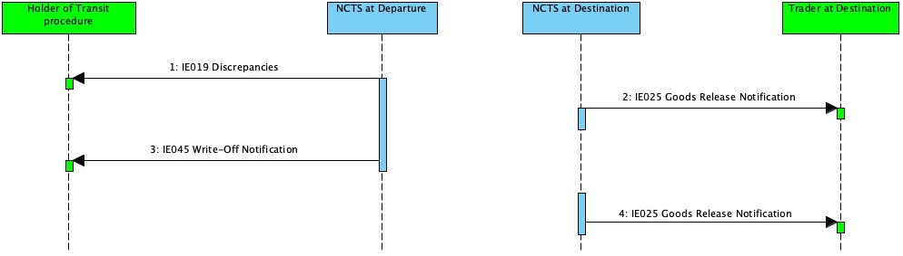

Figure 2: Release of a Guarantee after resolution of major discrepancies in the destination control results - Sequence Diagram

#### State Diagrams

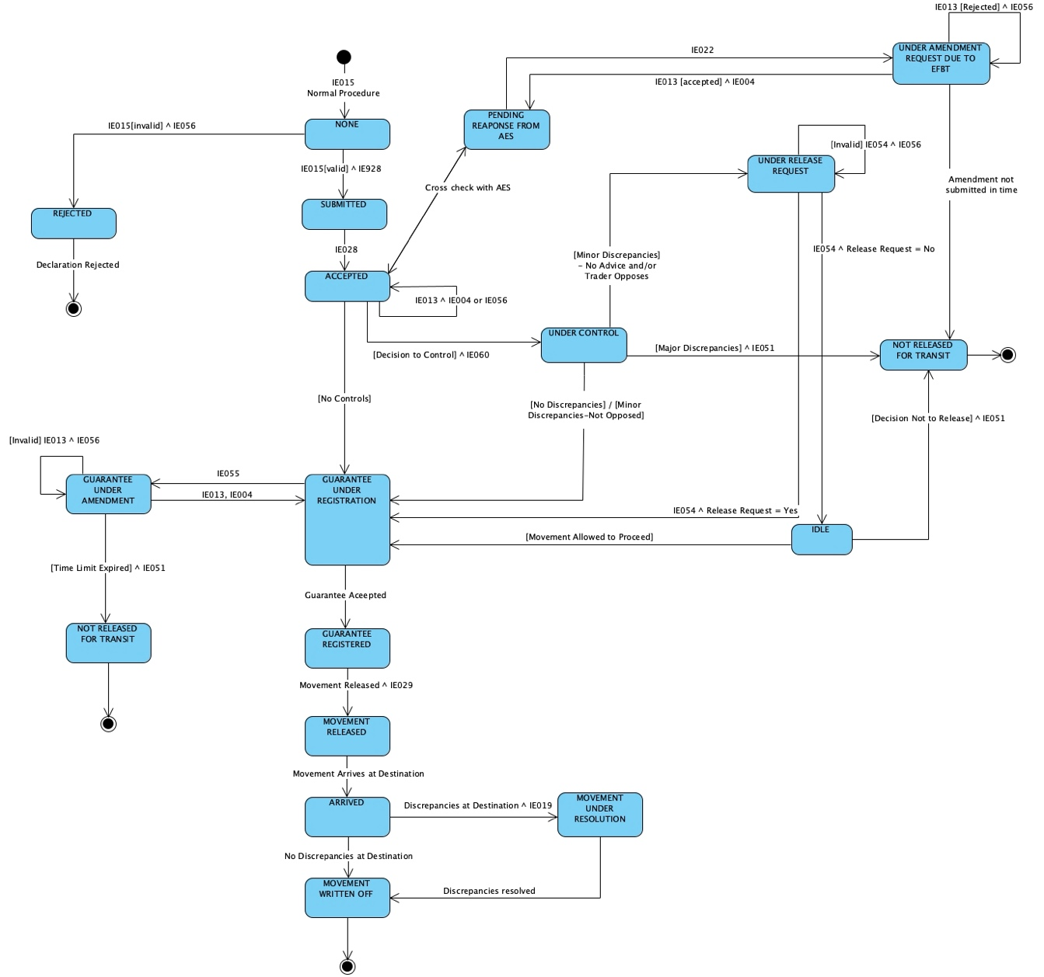

Figure 3: Standard Transit Procedure at Departure - State Diagram

For the State diagram at the Office of Destination see: *Figure 20: Transit Procedure at Office of Destination - State Diagram*

#### Use Case Summary

This scenario outlines the overview of the basic standard transit procedure when the goods are presented without delay by the Holder of the Transit Procedure.

##### Core flow at Office of Departure - Standard Transit Procedure

1. The Holder of the Transit Procedure submits a transit declaration to the Office of Departure with the ‘Declaration Data’ (IE015) message
2. The declaration is syntactically valid
3. *The state of the movement at the Office of Departure is set to “None”*
4. The declaration is logically valid
5. The declaration is submitted under normal procedure
6. NCTS acknowledges the reception of the transit declaration with the ‘Positive Acknowledge’ (IE928) message
7. *The state of the movement at the Office of Departure is set to “Submitted”*
8. NCTS communicates the MRN to the Holder of the Transit Procedure with the ‘MRN Allocated’ (IE028) message
9. *The state of the movement at the Office of Departure is set to “Accepted”*
10. *The state of the movement at the Office of Departure is set to “Guarantee under registration”*
11. The guarantee is accepted.
12. *The state of the transit declaration at the Office of Departure is set to “Guarantee registered”*
13. The Office of Departure decide to release the movement
14. *The state of the transit declaration at the Office of Departure is set to “Movement released”*
15. NCTS sends the ‘Release for Transit’ (IE029) message to Holder of the Transit Procedure
16. *The state of the movement at the Office of Departure is set to “**Movement written off**”*
17. NCTS sends the ‘Write-Off Notification’ (IE045) message to the Holder of the Transit Procedure.

**Printout of Transit Accompanying Document (TAD)**

1. The Holder of the Transit Procedure selects the ‘Print TAD’ action from the NCTS screens
2. NCTS creates a pdf with the Transit Accompanying Document
3. The Holder of the Transit Procedure or the Customs Officer prints the TAD

**Alternative flow at Office of Departure - Standard Transit Procedure – Declaration is Syntactically Invalid**

1. The Holder of the Transit Procedure submits a transit declaration to the Office of Departure with the ‘Declaration Data’ (IE015) message
2. The declaration is syntactically invalid
3. NCTS sends an IE917 XML NACK message to the Trader

**Alternative flow - The Transit declaration is logically invalid - Rejection of transit declaration**

1. The Holder of the Transit Procedure submits a Transit Declaration (IE015)
2. The IE015 message is syntactically valid
3. *The state of the movement at the Office of Departure is set to “None”*
4. The declaration is logically invalid
5. NCTS sends to the Holder of the Transit Procedure the ‘Rejection from Office of Departure’ (IE056) message
6. *The state of the movement at the Office of Departure is set to* *Rejected*
7. The business flow of the transit procedure ends here.

**Alternative flow: Release for transit refused for safety and security reasons**

1. The transit declaration and risk results show high risk with a threat to safety and security
2. NCTS sends the ‘No Release for Transit’ (IE051) message to the Holder of the Transit Procedure
3. *The state of the movement at the Office of Departure becomes “Not released for Transit”*
4. The business flow of the transit procedure ends here.

**Alternative flow: Release for transit refused due to guarantee registration failure**

1. The result of the guarantee check is not successful
2. *The state of the movement at the Office of Departure is set to “Guarantee under amendment“*
3. The Holder of the Transit Procedure is notified with the ‘Guarantee Not Valid’ (IE055) message since the declared guarantee is not valid
4. The Holder of the Transit Procedure needs to amend the invalid guarantee by sending the ‘Declaration Amendment’ (IE013) message
5. The Holder of the Transit Procedure sends no ‘Declaration Amendment’ (IE013) within the foreseen time limit
6. The movement is not released for transit and the ‘No Release for Transit’ (IE051) message is sent to the Holder of the Transit Procedure
7. *The state of the movement at the Office of Departure is set to “Not released for transit”*
8. The business flow of the transit operation ends here.

**Alternative flow - Controls will be performed at Office of Departure**

1. The Office of Departure decides to control the transit movement
2. NCTS sends the ‘Control Decision Notification’ (IE060) message to the Holder of the Transit Procedure to notify about the upcoming control activities (having the data element TRANSIT OPERATION-Notification type = ‘0-Decision to Control (and requested documents if needed)’)
3. *The state of the movement at the Office of Departure is set to “Under control”*

The business flow of the transit procedure may continue with one (1) of the following alternatives:

* Control results at the Office of Departure are satisfactory: in that case, the business flow continues from (*10* *The state of the movement at the Office of Departure is set to “Guarantee under registration”*)
* Control results at the Office of Departure show minor discrepancies (not opposed by Holder of the Transit Procedure): the business flow continues from (*10* *The state of the movement at the Office of Departure is set to “Guarantee under registration”*)
* Control results at the Office of Departure show minor discrepancies (Holder of the Transit Procedure does not provide advice and/or opposes these minor discrepancies): please refer to: *3.1.1.3.2 Minor Discrepancies found during Control*
* Control results at the Office of Departure are unsatisfactory:
  + The movement is not released for transit
  + The ‘No Release for Transit’ (IE051) message is sent to the Holder of the Transit Procedure.
  + *The state of the movement at the Office of Departure is set to “Not released for transit”*. This is a final state.

##### Minor Discrepancies found during Control

If Control reveals minor discrepancies, the Holder of the Transit Procedure needs to provide their advice on the proposed revision(s) for these minor discrepancies.

###### The Holder of the Procedure gives the advice right away

The Office of Departure revises the declaration data based on the results of control and the ‘Satisfactory’ control results code is registered

###### The Holder of the Transit Procedure does not provide any advice right away after the control

**Positive release request with release for transit**

1. The results of the control activity indicate minor discrepancies and advice is needed from the Holder of the Transit Procedure
2. The Holder of the Transit Procedure does not provide advice immediately
3. The status of the movement at the Office of Departure is set to “Under release request”
4. The Holder of the Transit Procedure sends the ‘Request of Release’ (IE054) to the Office of Departure
5. The 'Request of Release' (IE054) message is valid
6. The IE054 contains the flag ‘Release Request’ set to “1-Yes” (i.e. the Holder of the Transit Procedure has accepted the revisions - No opposition on minor revisions)
7. The business flow of the transit procedure continues from (*10* *The state of the movement at the Office of Departure is set to “Guarantee under registration”*)

**Negative release request**

1. The results of the control activity indicate minor discrepancies and advice is needed from the Holder of the Transit Procedure
2. The Holder of the Transit Procedure does not provide advice immediately
3. The status of the movement at the Office of Departure is set to “Under release request”
4. The Holder of the Transit Procedure sends the ‘Request of Release’ (IE054) to the Office of Departure
5. The 'Request of Release' (IE054) message is valid
6. The IE054 contains the flag ‘Release Request’ set to “0-No” (i.e. the Holder of the Transit Procedure has rejected the discrepancies - Opposition on minor revisions)
7. The state of the movement is set to “Idle”
8. The Office of Departure has to make the final decision whether to release or not the movement for transit. The business flow of the transit procedure can continue with one (1) of the following two (2) alternatives:

* In case the Office of Departure decides to allow the movement to proceed towards release for transit despite the fact that there are minor discrepancies, the business flow continues from (*10* *The state of the movement at the Office of Departure is set to “Guarantee under registration”*)
* In case the Office of Departure decides not to release the movement:
* The movement is not released for transit
* The ‘No Release for Transit’ (IE051) message is sent to the Holder of the Transit Procedure.
* The state of the movement at the Office of Departure is set to “Not released for transit”. This is a final state.

**Release request rejected**

1. The results of the control activity indicate minor discrepancies and advice is needed from the Holder of the Transit Procedure
2. The Holder of the Transit Procedure does not provide advice immediately
3. The status of the movement at the Office of Departure is set to “Under release request”
4. The Holder of the Transit Procedure sends the ‘Request of Release’ (IE054) to the Office of Departure
5. The ‘Request of Release’ (IE054) message is invalid
6. NCTS sends the ‘Rejection from Office of Departure’ (IE056) to the Holder of the Transit Procedure
7. The Holder of the Transit Procedure re-submits another ‘Request of Release’ (IE054) message that is considered valid.
8. The business flow of the transit procedure continues with one (1) of the following two (2) alternatives:

* As a “Positive release request with release for transit”
* As a “Negative release request”

**Alternative flow - Release of a Guarantee after resolution of major discrepancies in the destination control results**

**Office of Departure: Release of a Guarantee after resolution of major discrepancies in the destination control results**

1. Major discrepancies are reported in the Office of Destination control results.
2. NCTS sends a ‘Discrepancies’ (IE019) message to the Holder of the Transit Procedure
3. *The status of the movement at the Office of Departure is set to ‘Movement under resolution’*
4. The discrepancies are resolved
5. *The status of the movement at the Office of Departure is set to ‘Movement written off’*
6. NCTS sends the ‘Write-off Notification’ (IE045) message to the Holder of the Transit Procedure
7. The movement is closed

**Office of Destination: Release of a Guarantee after resolution of major discrepancies in the destination control results**

1. NCTS notifies the Trader at Destination for the major discrepancies with the ‘Goods Release Notification’ (IE025) message (i.e. Release indicator is set to ‘2- Partial release of goods’ or ‘4-No Release’)
2. *The status of the movement at the Office of Destination is set to ‘Waiting for discrepancies resolution’*
3. The discrepancies are resolved
4. NCTS notifies the Trader at Destination with the ‘Goods Release Notification’ (IE025) message (i.e. Release indicator is set to ‘1- Full release of goods (as per declaration) - Movement closed’ or ‘3- Partial release of goods - Movement closed’)
5. *The status of the movement at the Office of Destination is set to ‘Goods released’*

##### Core flow at Office of Destination - Standard Transit Procedure

1. The movement arrives at the Office of Destination
2. The Arrival Notification is submitted under normal procedure
3. *The state of the movement at the Office of Destination is set to “Arrival Accepted”*
4. The goods are released from transit
5. NCTS sends the ‘Goods Released Notification’ (IE025) message to the Trader at Destination (i.e. “Release Indicator” flag is equal to “1-Full release of goods (as per declaration) - Movement closed”).
6. *The state of the movement at the Office of Destination is set to “Goods Released”*

**Alternative flow - Invalid Arrival Notification**

This flow describes the case when the Trader at Destination sends the ‘Arrival Notification’ (IE007) to an Actual Office of Destination that is invalid in terms of message structure and Rules/Conditions

1. The movement arrives at the Office of Destination
2. The Trader at Destination announces it by submitting the ‘Arrival Notification’ (IE007) message
3. The IE007 message is logically invalid
4. The Office of Destination notifies the Trader at Destination by sending the ‘Rejection from Office of Destination’ (IE057) message
5. The Trader at Destination sends again another ‘Arrival Notification’ (IE007) to the Office of Destination
6. The IE007 message is logically valid
7. *The state of the movement at the Office of Destination is set to “Arrival accepted”*

**Alternative flow - Controls will be performed at Office of Destination**

The Customs Officer at Destination evaluates the risk results and decides to control the movement. One of the following flows will be executed:

**Major Discrepancies found during control at the Office of Destination - Resolved before the expiration of resolution timer**

1. Control is performed at the Office of Destination and major discrepancies are reported
2. *The state of the movement at the Office of Destination is set to ‘Waiting for discrepancies resolution’*
3. The Office of Destination sends the ‘Goods Release Notification’ (IE025) message to the Trader at Destination to notify them that the transit procedure has not ended correctly at the Office of Destination due to the existence of major discrepancies in the destination’s control results (i.e. Release indicator is NOT equal to ‘1-Full release of goods (as per declaration) - Movement closed’)

Note: The Office of Destination that sends this first ‘Goods Release Notification’ (IE025) message indicates those consignment items (i.e. type and quantity) of the transit movement, if any, that can be released to the next procedure (i.e. Release indicator is set to ‘2- Partial release of goods’). Indicatively, if the Office of Destination is located in the Union, the non-Union goods can be placed to the temporary storage or in the case of Union Goods, they can be released for other activities (e.g. sale).

Alternatively, the Office of Destination may indicate in the first ‘Goods Release Notification’ (IE025) message that no consignment item of the transit movement can be released to the next procedure (i.e. Release indicator is set to ‘4- No release’).

1. The major discrepancies are resolved
2. *The state of the movement at the Office of Destination is set to ‘Goods released’.*
3. The Office of Destination sends the ‘Goods Release Notification’ (IE025) message to the Trader at Destination as a notification that the transit procedure has ended successfully
4. All the goods can be released from transit (i.e. Release indicator is equal to ‘1- Full release of goods (as per declaration) - Movement closed’)

Note:In case there are house consignments/ consignment items that cannot be justified as released from the transit procedure when the transit movement is closed the Office of Destination may send the ‘Goods Release Notification’ (IE025) message specifying only those goods that are released from Transit, by having the Release indicator equal to ‘3-Partial release of goods - Movement closed’ --- CONSINMENT DATA Group will be used to indicate the goods that are partially released and Movement is closed’

**Office of Departure - Major Discrepancies found during control at the Office of Destination - Resolved before the expiration of resolution timer**

1. *The state of the movement at the Office of Departure is set to ‘Movement under resolution’*
2. The Office of Departure notifies the Holder of the Transit Procedure that major discrepancies are reported with the ‘Discrepancies’ (IE019) message
3. The Office of Departure resolves the major discrepancies
4. *The state of the movement at the Office of Departure is set to ‘Movement written off’*
5. The Office of Departure sends the ‘Write-Off Notification’ (IE204) message to the Holder of the Transit Procedure
6. The transit procedure is discharged
7. The guarantee amount used to secure the transit movement is released

**Office of Departure - Major Discrepancies found during control at the Office of Destination - Resolved after the expiration of resolution timer**

1. A period of thirteen (13) days has passed from the day that major discrepancies are reported
2. The major discrepancies are still unresolved
3. *The state of the movement at the Office of Departure is set to Movement under resolution*
4. The major discrepancies are resolved
5. *The state of the movement at the Office of Departure is set to ‘Movement written off’*
6. The movement can now be discharged at the Office of Departure
7. The guarantee amount used to secure the transit movement can be released

## Specific Scenarios at Office of Departure (DEP)

### Declaration Lodged Prior to Presentation of Goods

#### Transit presentation notification

The Transit Customs declaration can be lodged for the purpose of risk analysis thirty (30) days prior to the presentation of the goods to the Office of Departure (i.e. the value of the ‘Additional Declaration Type’ is equal to “D” in the ‘Declaration Data’ (IE015) message).

**NOTE:** There is no conflict to have Simplified Procedure and Pre-Lodged Declaration. The declaration is re-validated after the reception of the CC170C, to ensure validity/consistency of the "CC015C + CC013C (if any) + CC170C" combined declaration. At the time the “Presentation Notification for the Pre-lodged Declaration” (IE170) is lodged with the final 'Location of goods', then the 'Location of goods' mentioned in the Authorization (i.e. type ACR) is checked. In case that this validation check shows different locations of goods then the transit declaration is rejected.

##### Sequence Diagram

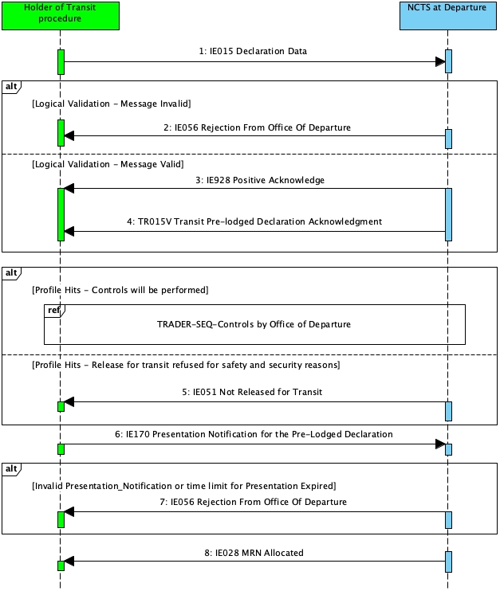

Figure 4: Transit presentation notification - Sequence Diagram

##### State Diagram

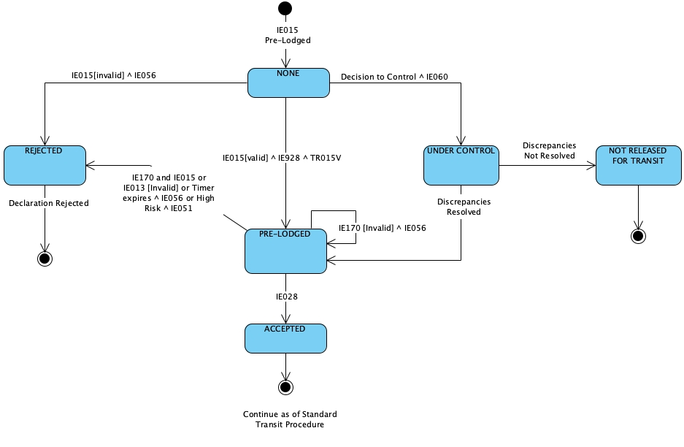

Figure 5: Transit presentation notification - State Diagram

##### Use Case Summary

**Core Flow - Transit presentation notification valid**

1. The Holder of the Transit Procedure submits a transit declaration to the Office of Departure with the ‘Declaration Data’ (IE015) with ‘Additional Declaration Type’ equal to ‘D’
2. The declaration is syntactically valid
3. *The state of the movement at the Office of Departure is set to “None”*
4. The declaration is logically valid
5. NCTS acknowledges the reception of the transit declaration with the ‘Positive Acknowledge’ (IE928) message
6. NCTS sends the ‘Transit Pre-lodged Declaration Acknowledgment’ (TR015V) message to the Holder of the Transit Procedure
7. *The state of the movement at the Office of Departure is set to “Pre-Lodged”*
8. The Office of Departure decides not to control the movement.
9. NCTS receives a ‘Presentation Notification for the Pre-Lodged Declaration’ (IE170) message from the Holder of the Transit Procedure
10. The ‘Presentation Notification for the Pre-Lodged Declaration’ (IE170) message is valid
11. NCTS communicates the MRN to the Holder of the Transit Procedure with the ‘MRN Allocated’ (IE028) message
12. *The state of the movement at the Office of Departure is set to “Accepted”*

The business flow of the transit procedure continues as of *Standard Transit Procedure (overview)*.

**Alternative flow at Office of Departure - Standard Transit Procedure – Declaration is Syntactically Invalid**

1. The Holder of the Transit Procedure submits a transit declaration to the Office of Departure with the 'Declaration Data' (IE015) with 'Additional Declaration Type' equal to 'D'
2. The declaration is syntactically invalid
3. Customs sends an IE917 XML NACK message to the Trader

**Alternative flow-Controls at Departure**

1. The Office of Departure selects the pre-lodged declaration for control of the goods prior to their presentation
2. If the Holder of the Transit Procedure is an AEO then NCTS notifies the Holder of the Transit Procedure about the intention to potentially control the goods, via the ‘Control Decision Notification’ (IE060) message (having the data element TRANSIT OPERATION-Notification type = ‘2-Intention to Control’)

*Note: There may be scenarios where the HTP will not receive the routing in advance of presentation IE170*

1. The flows described in section *(3.9.1 Controls at Office of Departure)* will be executed

**Alternative flow: Release for transit refused for safety and security reasons**

1. The transit declaration and risk results show high risk with a threat to safety and security
2. NCTS sends the ‘No Release for Transit’ (IE051) message to the Holder of the Transit Procedure
3. *The state of the movement at the Office of Departure becomes “Not released for Transit”*
4. The business flow of the transit procedure ends here.

**Alternative flow - Presentation Notification re-validation fails**

1. NCTS re-validates the Transit Declaration information (considering the ‘Declaration Data’ (IE015) and any latest ‘Declaration Amendment’ (IE013))
2. The validation is unsuccessful (i.e. reference data are not valid)
3. The pre-lodged Transit Declaration is rejected.
4. NCTS sends to the Holder of the Transit Procedure a ‘Rejection from Office of Departure’ (IE056) giving the reason for rejection
5. *The state of the movement changes to “Rejected*”
6. This is a final state and the scenario stops here. When a Transit Declaration has been rejected, the normal way of proceeding is the Holder of the Transit Procedure to send a new ‘Declaration Data’ (IE015).

**Alternative flow - Transit presentation notification not valid**

1. NCTS receives a ‘Presentation Notification for the Pre-Lodged Declaration’ (IE170) message from the Holder of the Transit Procedure
2. The ‘Presentation Notification for the Pre-Lodged Declaration’ (IE170) is invalid (i.e. in terms of message structure and R/Cs)
3. NCTS rejects the IE170
4. NCTS sends to the Holder of the Transit Procedure the ‘Rejection from Office of Departure’ (IE056) message.
5. The Holder of the Transit Procedure however has the right to resend a valid ‘Presentation Notification for the Pre-Lodged Declaration’ (IE170) message within the time limit of the thirty (30) days.

**Alternative flow Await Presentation Notification expires**

1. The time limit for the lodgement of the Presentation Notification expires
2. The Holder of the Transit Procedure has not notified the Office of Departure for the presentation of goods with the ‘Presentation Notification for the Pre-Lodged Declaration’ (IE170) message
3. No further ‘Presentation Notification for the Pre-Lodged Declaration’ (IE170) is accepted afterwards
4. The Holder of the Transit Procedure is notified with the message ‘Rejection from Office of Departure’ (IE056) by the Office of Departure
5. *The status of the transit movement at the Office of Departure is set to “Rejected”*
6. The business flow of the transit procedure ends here.

#### Correction of the pre-lodged declaration prior to presentation of goods

##### Sequence Diagram

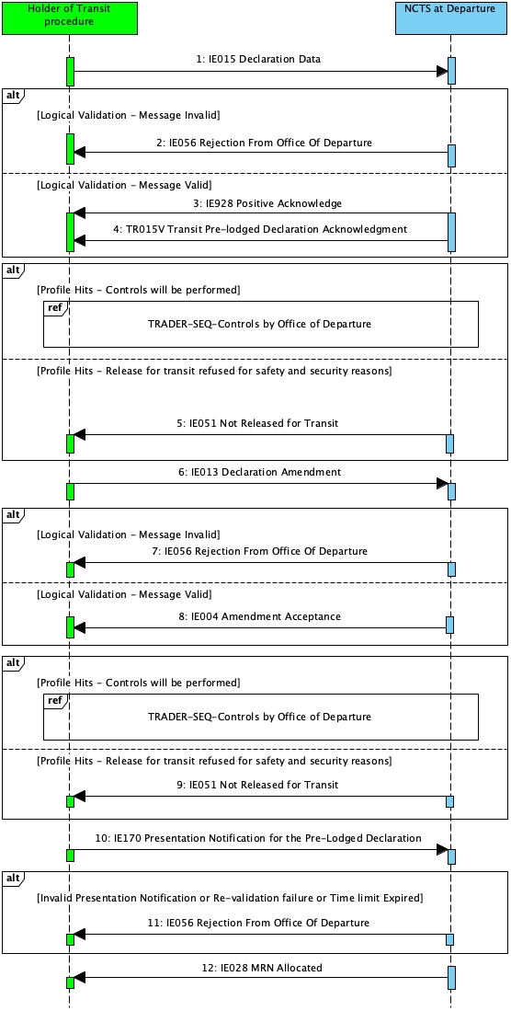

Figure 6: Correction of the pre-lodged declaration - Sequence Diagram

##### State Diagram

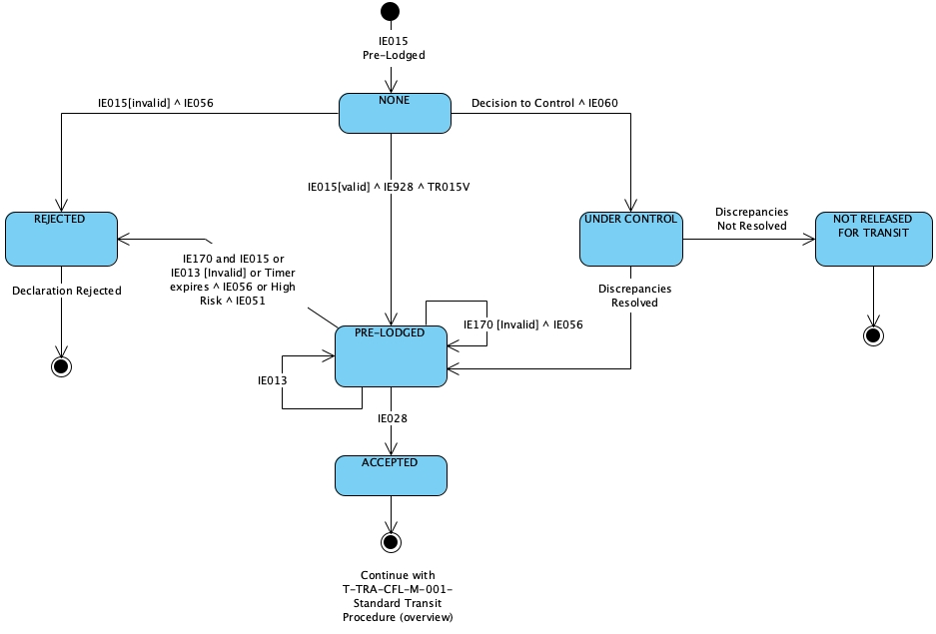

Figure 7: Correction of the pre-lodged declaration - State Diagram

##### Use Case Summary

Before the goods are presented and within the time limit for the presentation of goods, the Holder of the Transit is allowed to correct the transit declaration.

1. The Holder of the Transit Procedure submits a transit declaration to the Office of Departure with the ‘Declaration Data’ (IE015) with ‘Additional Declaration Type’ equal to ‘D’
2. The declaration is syntactically valid
3. *The state of the movement at the Office of Departure is set to “None”*
4. The declaration is logically valid
5. NCTS acknowledges the reception of the transit declaration with the ‘Positive Acknowledge’ (IE928) message
6. NCTS sends the ‘Transit Pre-lodged Declaration Acknowledgment’ (TR015V) message to the Holder of the Transit Procedure
7. *The state of the movement at the Office of Departure is set to “Pre-Lodged”*
8. The Holder of the Transit Procedure decides to correct the transit declaration
9. The Holder of the Transit Procedure submits the ‘Declaration Amendment’ (IE013) message
10. The declaration amendment is syntactically valid
11. The declaration amendment is logically invalid
12. NCTS sends to the Holder of the Transit Procedure the ‘Rejection from Office of Departure’ (IE056) message
13. The Holder of the Transit Procedure submits a new ‘Declaration Amendment’ (IE013) message
14. The declaration amendment is syntactically valid
15. The declaration amendment is logically valid
16. NCTS sends to the Holder of the Transit Procedure the ‘Amendment Acceptance’ (IE004) message.
17. *The state of the movement at the Office of Departure remains Pre-Lodged*
18. The time limit for the presentation of goods is not reset if the Holder of the Transit Procedure sends a correction to the transit declaration
19. The Holder of the Transit Procedure submits ‘Presentation Notification for the Pre-Lodged Declaration’ (IE170) message to the Office of Departure
20. The Presentation Notification is syntactically valid
21. The Presentation Notification is logically valid
22. In addition, based on the information contained in the ‘Presentation Notification for the Pre-Lodged Declaration’ (IE170) message, NCTS re-validates the Transit Declaration information (considering the ‘Declaration Data’ (IE015) and any latest ‘Declaration Amendment’ (IE013)) and ensures the validity of the reference data.

Note: The core flow for the Presentation Notification is presented in ‘*3.2.1.1Transit presentation notification’*

1. The additional checks are successful, the transit declaration is accepted
2. NCTS sends to the Holder of the Transit Procedure the ‘MRN Allocated’ (IE028) message

The business flow of the transit procedure continues as of ‘*3.1.1 Standard Transit Procedure (overview)’*

**Alternative flow-Controls at Departure**

1. The Office of Departure selects the pre-lodged declaration for control of the goods prior to their presentation
2. If the Holder of the Transit Procedure is an AEO then NCTS notifies the Holder of the Transit Procedure about the intention to potentially control the goods, via the ‘Control Decision Notification’ (IE060) message (having the data element TRANSIT OPERATION-Notification type = ‘2-Intention to Control’)
3. The flows described in section *(3.9.1 Controls at Office of Departure)* will be executed

**Alternative flow: Release for transit refused for safety and security reasons**

1. The transit declaration and risk results show high risk with a threat to safety and security
2. NCTS sends the ‘No Release for Transit’ (IE051) message to the Holder of the Transit Procedure
3. *The state of the movement at the Office of Departure becomes “Not released for Transit”*
4. The business flow of the transit procedure ends here.

###### Alternative flow – Revalidation of Transit Declaration fails

1. The re-validation of the Transit Declaration information (considering the ‘Declaration Data’ (IE015) and any latest ‘Declaration Amendment’ (IE013)) is unsuccessful (i.e. reference data are not valid)
2. The pre-lodged Transit Declaration is rejected
3. NCTS sends to the Holder of the Transit Procedure a ‘Rejection from Office of Departure’ (IE056) giving the reason for rejection
4. *The state of the movement changes to Rejected*

#### Cancellation of the pre-lodged declaration prior to presentation of goods

##### Sequence Diagram

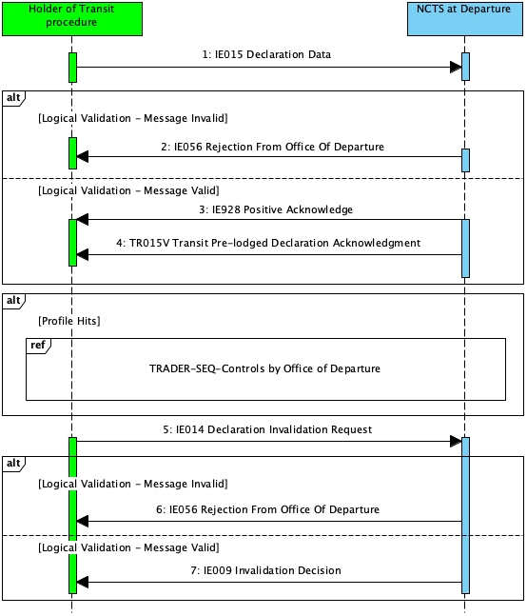

Figure 8: Cancellation of the pre-lodged declaration prior to presentation of goods - Sequence Diagram

##### State Diagram

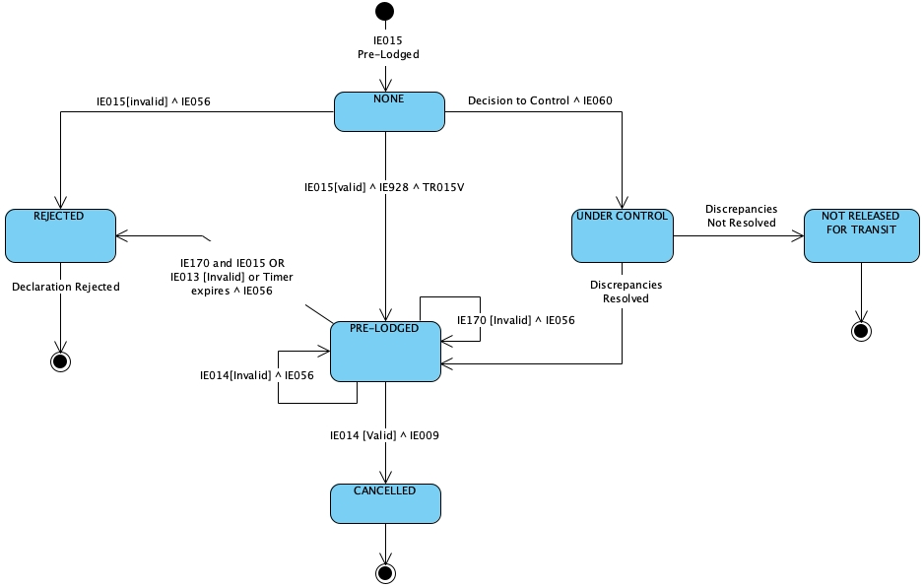

Figure 9: Cancellation of the pre-lodged declaration prior to presentation of goods - State Diagram

##### Use Case Summary

###### Cancellation of the pre-lodged declaration prior to presentation of goods

Before the goods are presented and within the time limit for the presentation of goods, the Holder of the Transit is allowed to cancel the transit declaration.

1. The Holder of the Transit Procedure submits a transit declaration to the Office of Departure with the ‘Declaration Data’ (IE015) with ‘Additional Declaration Type’ equal to ‘D’
2. The declaration is syntactically valid
3. *The state of the movement at the Office of Departure is set to “None”*
4. The declaration is logically valid
5. NCTS acknowledges the reception of the transit declaration with the ‘Positive Acknowledge’ (IE928) message
6. NCTS sends the ‘Transit Pre-lodged Declaration Acknowledgment’ (TR015V) message to the Holder of the Transit Procedure
7. *The state of the movement at the Office of Departure is set to “Pre-Lodged”*
8. The Holder of the Transit Procedure decides to cancel the transit declaration
9. The Holder of the Transit Procedure submits the ‘Declaration Invalidation Request’ (IE014) message
10. The invalidation request is syntactically valid
11. The invalidation request is logically valid
12. NCTS sends a positive decision with 'Invalidation Decision' (IE009) to the Holder of the Transit Procedure
13. *The state of the movement at the Office of Departure is set to “Cancelled”*

###### Alternative flow - Invalid 'Declaration Invalidation Request'

1. The Holder of the Transit Procedure decides to cancel the pre-lodged declaration
2. The Holder of the Transit Procedure submits the 'Declaration Invalidation Request' (IE014) message to the Office of Departure
3. The invalidation request is syntactically valid
4. The invalidation request is logically invalid
5. The invalidation request is rejected
6. NCTS sends to the Holder of the Transit Procedure a 'Rejection from Office of Departure' (IE056) giving the reason for rejection
7. *The state of the movement remains unchanged*

#### Simplified procedure at Departure

##### Sequence Diagram

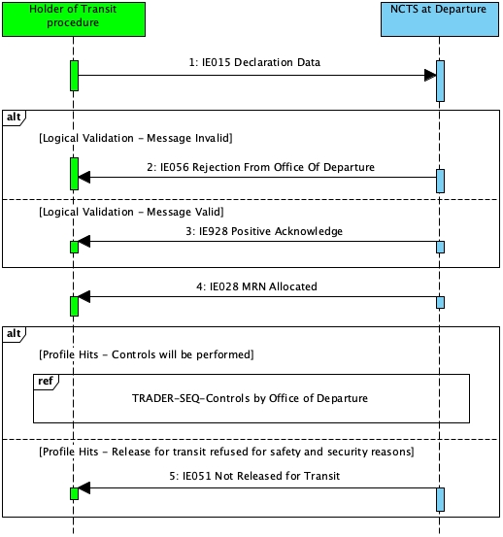

Figure 10: Simplified procedure at Departure - Sequence Diagram

##### State Diagram

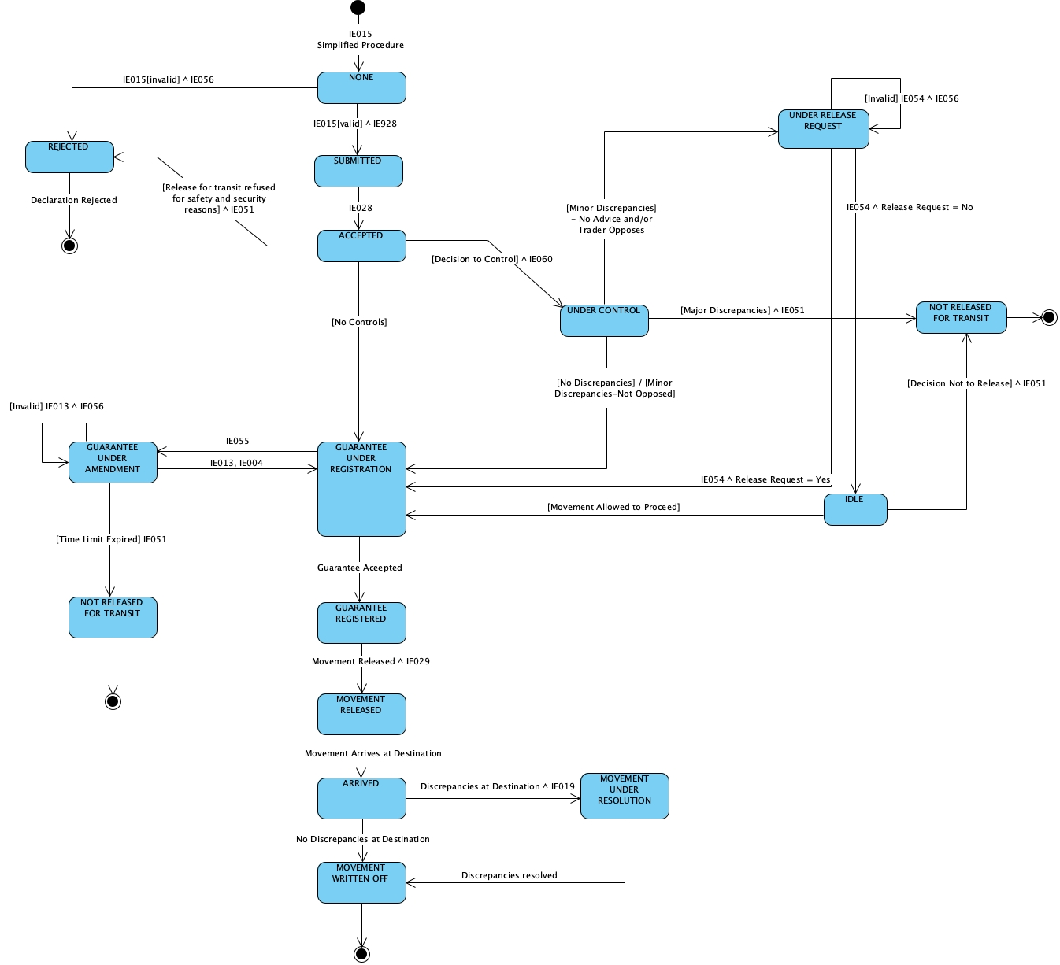

Figure 11: Simplified procedure at Departure - State Diagram

##### Use Case Summary

The Holder of the Transit Procedure / Authorised Consignor initiates the Union / Common Transit movement by sending the transit declaration data (IE015) to the Customs Office of Departure. The declaration must be simplified:

* IE015.AUTHORISATION.Type = 'C521' followed by a valid authorisation reference number
* TRANSIT OPERATION.Limit date is present

**Core Flow - Simplified procedure at departure**

1. The Holder of the Transit Procedure submits a transit declaration the ‘Declaration Data’ (IE015) under simplified procedure
2. The declaration is syntactically valid
3. *The state of the movement at the Office of Departure is set to "None"*
4. The declaration is logically valid
5. The declaration is submitted under simplified procedure
6. NCTS acknowledges the reception of the transit declaration with the ‘Positive Acknowledge’ (IE928) message
7. *The state of the movement at the Office of Departure is set to “Submitted”*
8. NCTS communicates the MRN to the Holder of the Transit Procedure with the ‘MRN Allocated’ (IE028) message
9. *The state of the movement at the Office of Departure is set to “Accepted”*
10. *The state of the movement at the Office of Departure is set to “Guarantee under registration”*
11. The guarantee is accepted.
12. *The state of the transit declaration at the Office of Departure is set to “Guarantee registered”*
13. The Office of Departure decide to release the movement.
14. *The state of the transit declaration at the Office of Departure is set to “Movement released”*

The business flow of the transit procedure continues from “*15 NCTS sends the ‘Release for Transit’ (IE029) message to Holder of the Transit Procedure”* of the Standard Transit Procedure (overview).

**Alternative flow at Office of Departure - Standard Transit Procedure – Declaration is Syntactically Invalid**

1. The Holder of the Transit Procedure submits a transit declaration to the Office of Departure with the ‘Declaration Data’ (IE015) message
2. The declaration is syntactically invalid
3. Customs sends an IE917 XML NACK message to the Trader

**Alternative flow - The Transit declaration is logically invalid - Rejection of transit declaration**

1. The Holder of the Transit Procedure submits a Transit Declaration (IE015)
2. The IE015 message is syntactically valid
3. *The state of the movement at the Office of Departure is set to “None”*
4. The declaration is logically invalid
5. NCTS sends to the Holder of the Transit Procedure the ‘Rejection from Office of Departure’ (IE056) message
6. *The state of the movement at the Office of Departure is set to* *Rejected*
7. The business flow of the transit procedure ends here.

**Alternative flow - Controls will be performed at Office of Departure**

The flow for the Controls to be performed at the Office of Departure is the same with the one described in section *3.1 Core Flow (CFL*)

**Alternative flow: Release for transit refused for safety and security reasons**

1. The transit declaration and risk results show high risk with a threat to safety and security
2. NCTS sends the ‘No Release for Transit’ (IE051) message to the Holder of the Transit Procedure
3. *The state of the movement at the Office of Departure becomes “Not released for Transit”*
4. The business flow of the transit procedure ends here.

### Amendment of Transit Declaration

#### Sequence Diagram

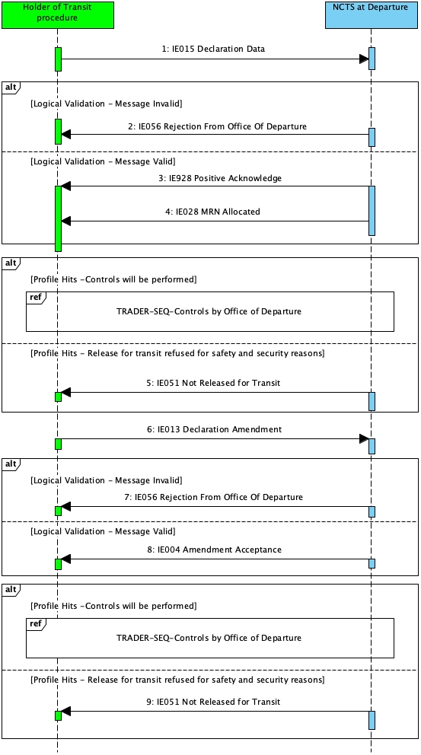

Figure 12: Amendment of Transit Declaration - Sequence Diagram

#### State Diagram

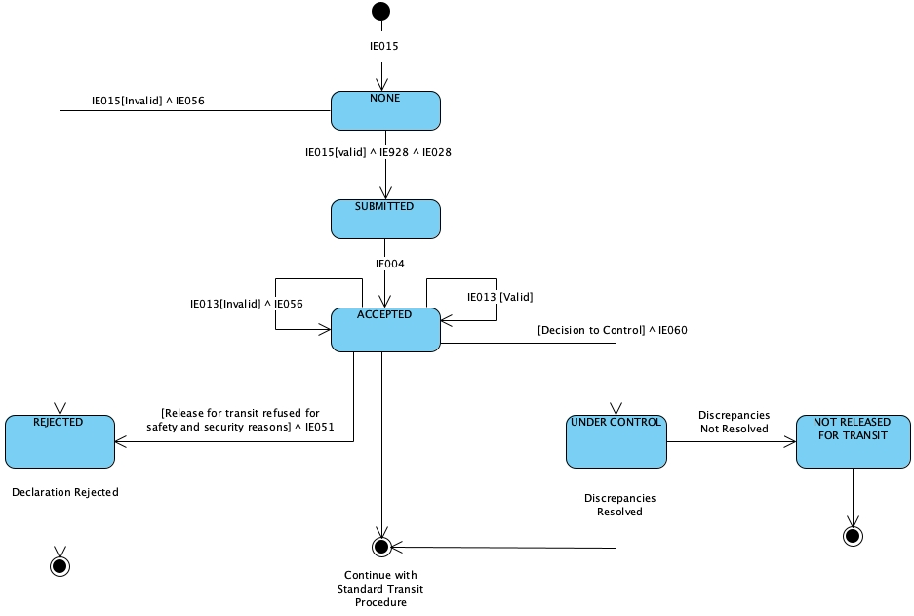

Figure 13: Amendment of Transit Declaration - State Diagram

#### Use Case Summary

Amendments made by the Holder of the Transit Procedure enable changes to the declaration data right until the movement is released for transit. No amendment requests by the Holder of the Transit Procedure are allowed before the declaration is accepted and after it is released for transit. Moreover, amendment requests are rejected when declaration is under the status Under control.

1. The Holder of the Transit Procedure submits a transit declaration to the Office of Departure with the ‘Declaration Data’ (IE015) message
2. The declaration is syntactically valid
3. *The state of the movement at the Office of Departure is set to “None”*
4. The declaration is logically valid
5. NCTS acknowledges the reception of the transit declaration with the ‘Positive Acknowledge’ (IE928) message
6. *The state of the movement at the Office of Departure is set to “Submitted”*
7. NCTS communicates the MRN to the Holder of the Transit Procedure with the ‘MRN Allocated’ (IE028) message
8. *The state of the movement at the Office of Departure is set to “Accepted”*
9. The Holder of the Transit Procedure decides to correct the transit declaration
10. The Holder of the Transit Procedure submits the ‘Declaration Amendment’ (IE013) message
11. The declaration amendment is syntactically valid
12. The declaration amendment is logically valid
13. NCTS accepts the amendment
14. NCTS sends to the Holder of the Transit Procedure the ‘Amendment Acceptance’ (IE004) message.
15. *The state of the movement at the Office of Departure remains “Accepted”*

The business flow of the transit procedure continues as of ‘*3.1.1 Standard Transit Procedure (overview)’*

**Alternative flow – Rejection of the Declaration Amendment**

1. The Holder of the Transit Procedure submits the ‘Declaration Amendment’ (IE013) message
2. The declaration amendment is syntactically valid
3. The declaration amendment is logically invalid
4. The amendment is rejected
5. NCTS sends to the Holder of the Transit Procedure a ‘Rejection from Office of Departure’ (IE056) giving the reason for rejection
6. The state of the movement does not change

**Alternative flow: Release for transit refused for safety and security reasons**

1. The *state of the movement at the Office of Departure is “Accepted”*
2. The transit declaration and risk results show high risk with a threat to safety and security
3. NCTS sends the ‘No Release for Transit’ (IE051) message to the Holder of the Transit Procedure
4. *The state of the movement at the Office of Departure becomes “Not released for Transit”*
5. The business flow of the transit procedure ends here.

### Invalidation of Transit Declaration

#### Invalidation request by the Holder of the Transit Procedure before release for transit

##### Sequence Diagram

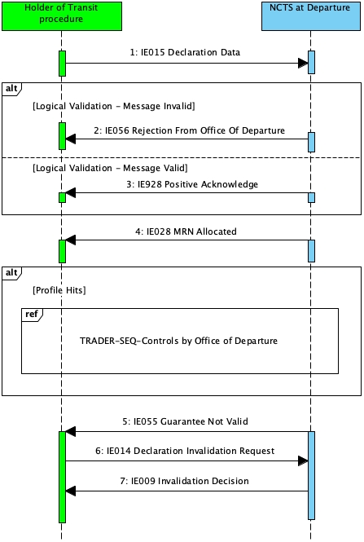

Figure 14: Invalidation request before release for transit - Sequence Diagram

##### State Diagram

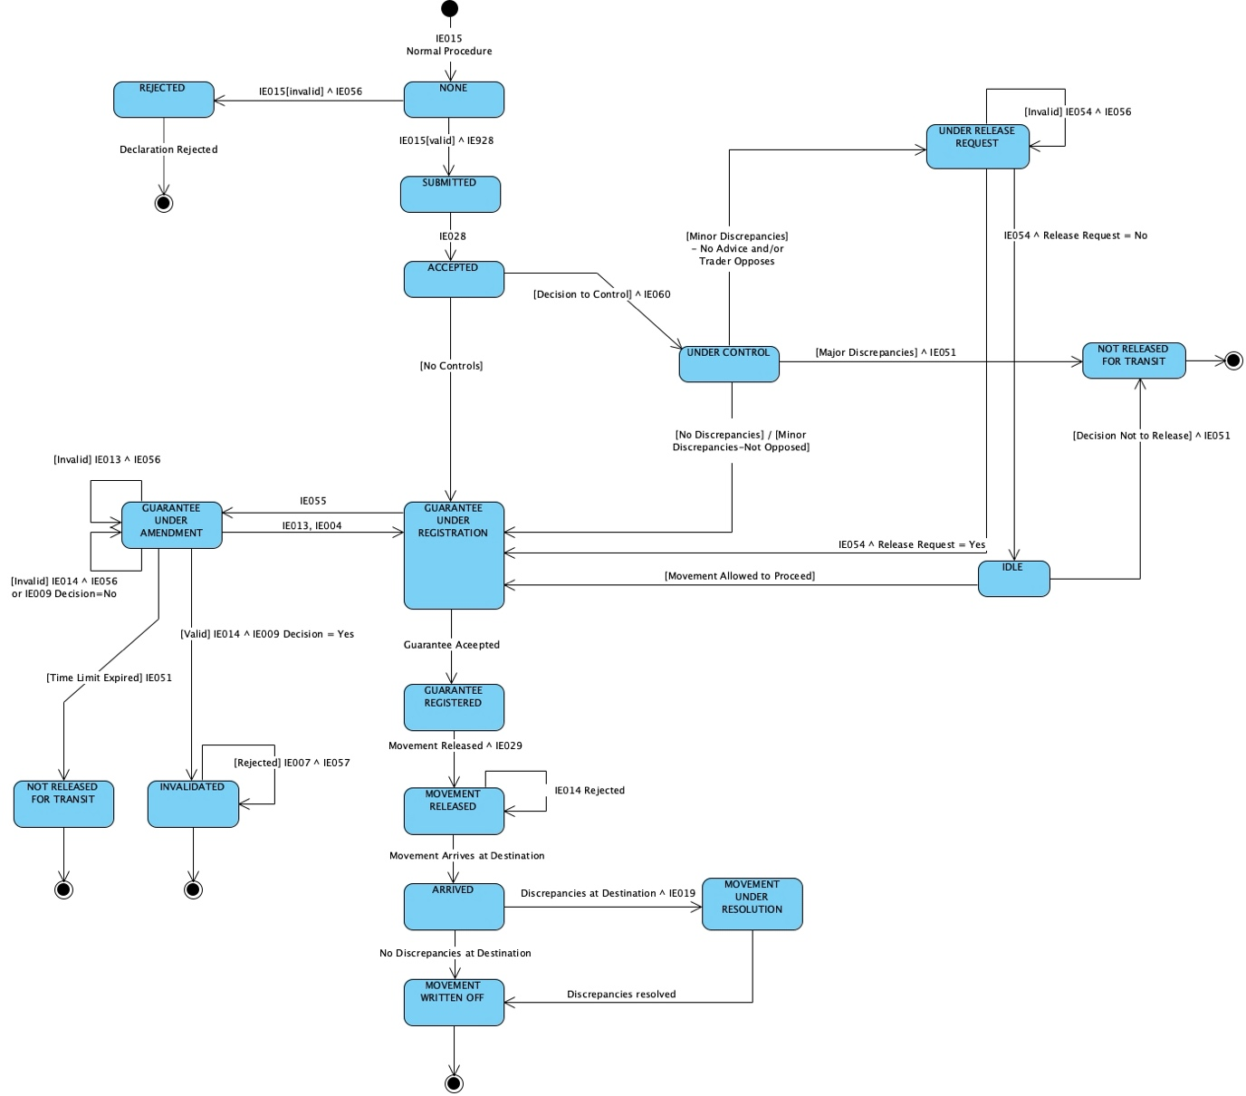

Figure 15: Invalidation request before release for transit - State Diagram

##### Use Case Summary

An already accepted transit declaration (i.e. after status Accepted) can be invalidated by the Holder of the Transit Procedure via the ‘Declaration Invalidation Request’ (IE014) message, but only before release for transit (i.e. before status Movement released).

Upon reception of the ‘Declaration Invalidation Request’ (IE014) message, the Office of Departure examines the request and informs the Holder of the Transit Procedure accordingly of the result of such request via the ‘Invalidation Decision’ (IE009) message. The invalidation decision by the Customs Officer at the Office of Departure can be positive or negative (“Decision” is set to “1=Yes” when it is positive or to “0=No” when it is negative)

However, where the Office of Departure has informed the Holder of the Transit Procedure of its intention to examine the goods with the ‘Control decision notification’ (IE060) message, a request for invalidation of the customs declaration will be automatically rejected.

Invalidation of the declaration can be performed under one (1) of the following conditions:

* The Holder of the Transit Procedure can electronically request invalidation of an accepted transit declaration before the goods are released for transit. Thus, invalidation can be requested while the movement’s status at the Office of Departure is under one (1) of the following: Accepted, Guarantee under registration, Guarantee under amendment, Guarantee registered, Idle, Under release request.

However, after release for transit, this invalidation request cannot be requested via the ‘Declaration Invalidation Request’ (IE014) message, but outside the system

After invalidation, no further actions are possible for the transit movement.

**Declaration Invalidation flow**

1. The Holder of the Transit Procedure submits a transit declaration to the Office of Departure with the ‘Declaration Data’ (IE015) message
2. The declaration is syntactically valid
3. *The state of the movement at the Office of Departure is set to “None”*
4. The declaration is logically valid
5. The declaration is submitted under normal procedure
6. NCTS acknowledges the reception of the transit declaration with the ‘Positive Acknowledge’ (IE928) message
7. *The state of the movement at the Office of Departure is set to “Submitted”*
8. NCTS communicates the MRN to the Holder of the Transit Procedure with the ‘MRN Allocated’ (IE028) message
9. *The state of the movement at the Office of Departure is set to “Accepted”*
10. *The state of the movement at the Office of Departure is set to “Guarantee under registration”*
11. The declared guarantee is not valid
12. *The state of the transit declaration at the Office of Departure is set to “Guarantee under amendment”*
13. The Holder of the Transit Procedure is notified with the ‘Guarantee Not Valid’ (IE055) message that the declared guarantee is not valid.
14. The Holder of the Transit Procedure submits the ‘Declaration Invalidation Request’ (IE014) message
15. The request is syntactically valid
16. The request is logically valid
17. The invalidation request is accepted and a positive ‘Invalidation Decision’ (IE009) message is send (i.e. “Decision” is set to “1=Yes”) to the Holder of the Transit Procedure
18. *The state of the movement at the Office of Departure is set to “Invalidated”*

#### Invalidation request by the Holder of the Transit Procedure after release for transit

##### Sequence Diagram

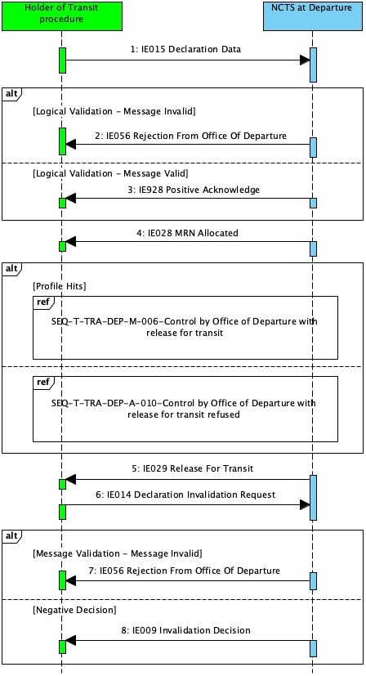

Figure 16: Invalidation request by the Holder of the Transit Procedure after release for transit - Sequence Diagram

##### State Diagram

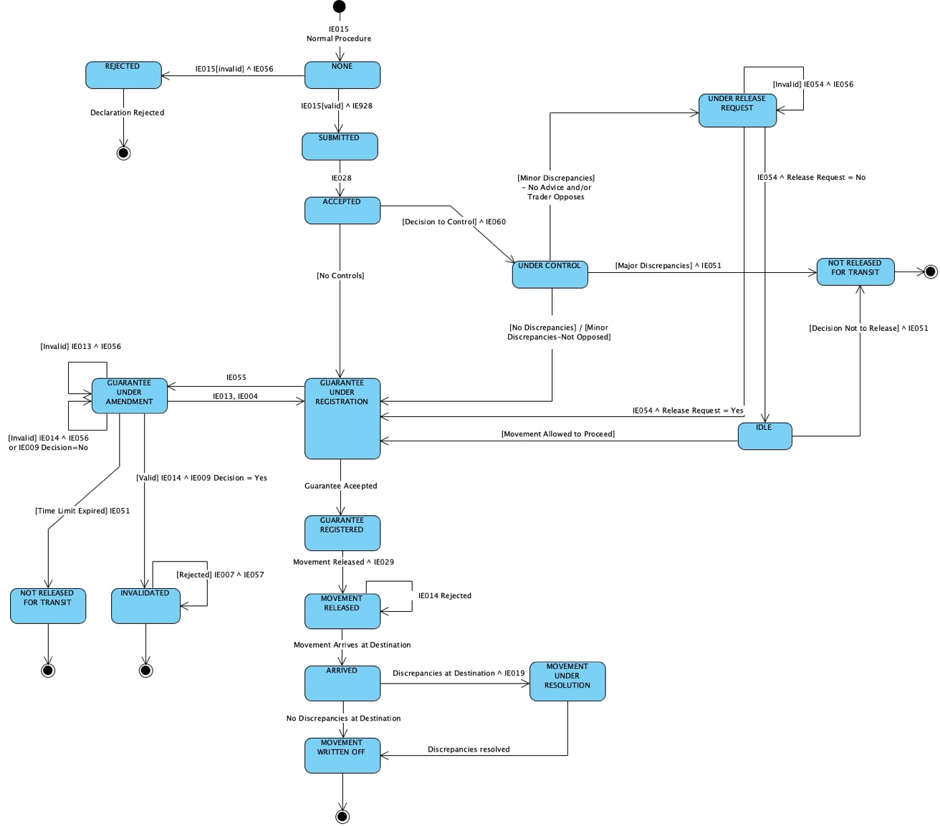

Figure 17: Invalidation request by the Holder of the Transit Procedure after release for transit - State Diagram

##### Use Case Summary

1. The Holder of the Transit Procedure sends the ‘Declaration Invalidation Request’ (IE014) message while the state of the movement at the Office of Departure is “*Movement released*”
2. The Office of Departure automatically rejects the ‘Declaration Invalidation Request’ (IE014) by notifying the Holder of the Transit Procedure with the ‘Invalidation Decision’ (IE009) message containing negative decision (i.e. “Decision” is set to “0=No”)
3. The state of the movement at the Office of Departure remains unchanged

The business flow of the transit operation continues as of the *Standard Transit Procedure (overview)* scenario.

#### Invalidation of a transit declaration after release for transit

##### Sequence Diagram

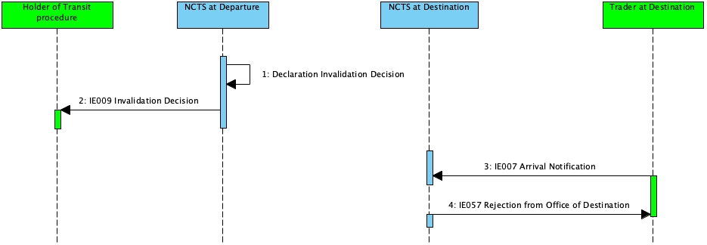

Figure 18: Invalidation of a transit declaration after release for transit - Sequence Diagram

##### State Diagram

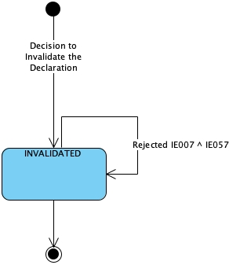

Figure 19: Invalidation of a transit declaration after release for transit - State Diagram

##### Use Case Summary

In this scenario, a transit declaration is invalidated after the goods are released for transit. There are two (2) specific cases when a transit declaration can be invalidated:

* Union goods have been declared in error for a transit procedure applicable only to Non-Union goods
* Goods have been erroneously declared under more than one (1) transit declaration.

1. The Office of Departure decides to invalidate the declaration. This means that all the possible running timers are stopped.
2. *The state of the movement at the Office of Departure is set to “Invalidated”*
3. The Holder of the Transit Procedure is notified with the ‘Invalidation Decision’ (IE009) message

**Office of Destination**

1. *The state of the movement at the Office of Destination is set to “Invalidated”*
2. The Trader at Destination submits the ‘Arrival Notification’ (IE007) message
3. The arrival notification is rejected with the ‘Rejection from Office of Destination’ (IE057) message
4. The business flow of the transit procedure ends here.

## Specific Scenarios at Office of Destination (DES)

### State Diagrams at Office of Destination

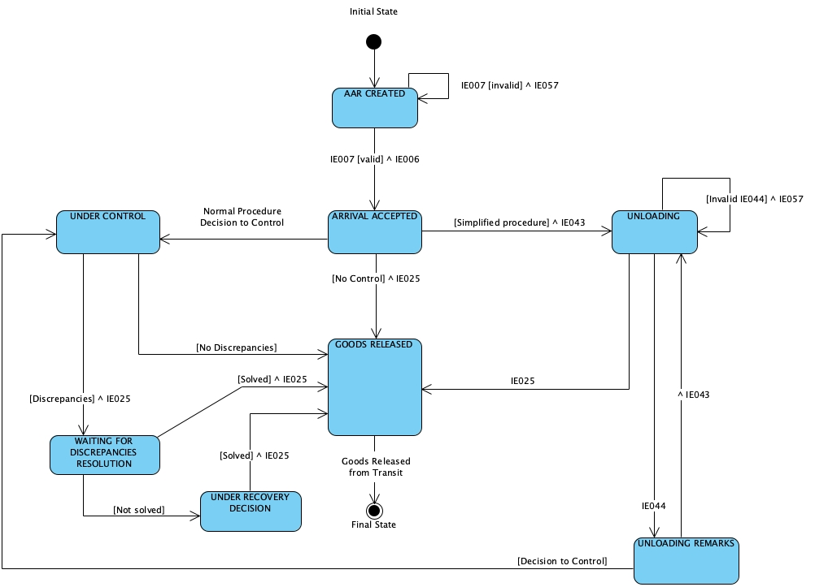

Figure 20: Transit Procedure at Office of Destination - State Diagram

### Simplified procedure at destination

#### Sequence Diagram

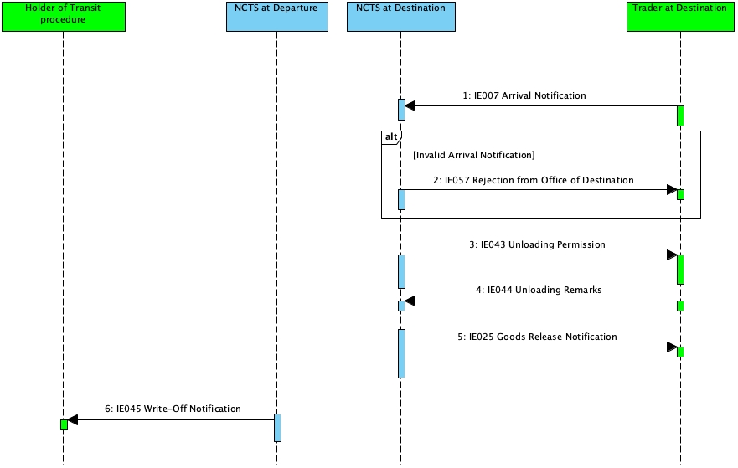

Figure 21: Simplified Procedure at destination - Sequence Diagram

#### Use Case Summary

##### Core flow at Office of Destination - Simplified procedure at destination without controls

1. Trader at Destination sends the ‘Arrival Notification’ (IE007) to the Office of Destination
2. The message is syntactically valid
3. The message is logically valid
4. *The state of the movement at the Office of Destination is set to ‘Arrival accepted’*
5. NCTS notifies the Trader at Destination that the unloading of the goods can be started by means of ‘Unloading Permission’ (IE043)
6. *The state of the movement at the Office of Destination is set to ‘Unloading’*
7. Unloading is completed
8. Trader at Destination sends the ‘Unloading Remarks’ (IE044) to the Office of Destination indicating that the unloading has been completed with no unloading remarks. (i.e. the ‘Unloading Remarks’ (IE044) message contains the flags Unloading completion = ‘1-Yes’ & Conform = ‘1-Yes’).
9. The goods are released from transit
10. The Office of Destination sends the ‘Goods Released Notification’ (IE025) message to the Trader at Destination. (i.e. “Release Indicator” flag is equal to “1-Full release of goods (as per declaration) - Movement closed”).
11. *The state of the movement at the Office of Destination is set to ‘Goods released’*
12. This is a final state.

##### Alternative flow at Office of Destination - Simplified procedure at destination with controls - Goods released

1. Trader at Destination sends the ‘Arrival Notification’ (IE007) to the Office of Destination
2. The message is syntactically valid
3. The message is logically valid
4. *The state of the movement at the Office of Destination is set to ‘Arrival accepted’*
5. The Office of Destination decides to control the transit movement
6. NCTS sends the ‘Control Decision Notification at Destination’ (TR060) message to the Trader at Destination to notify about the upcoming control activities
7. *The state of the movement at the Office of Destination is set to “Under control”*
8. The results of the control activity are registered in NCTS
9. The goods are released from transit
10. The Office of Destination sends the ‘Goods Released Notification’ (IE025) message to the Trader at Destination. (i.e. “Release Indicator” flag is equal to “1-Full release of goods (as per declaration) - Movement closed”).
11. *The state of the movement at the Office of Destination is set to ‘Goods released’*
12. This is a final state.

##### Alternative flow at Office of Destination - Simplified procedure at destination with controls - Goods not released

1. Trader at Destination sends the ‘Arrival Notification’ (IE007) to the Office of Destination
2. The message is syntactically valid
3. The message is logically valid
4. *The state of the movement at the Office of Destination is set to ‘Arrival accepted’*
5. The Office of Destination decides to control the transit movement
6. NCTS sends the ‘Control Decision Notification at Destination’ (TR060) message to the Trader at Destination to notify about the upcoming control activities
7. *The state of the movement at the Office of Destination is set to “Under control”*
8. The results of the control activity are registered in NCTS
9. The goods are released from transit
10. The Office of Destination sends the ‘Goods Released Notification’ (IE025) message to the Trader at Destination. (i.e. “Release Indicator” flag is equal to “4 - No release of goods”)
11. The movement is under “Discrepancies Resolution”
12. This is a final state.

**Alternative flow: Unloading Permission Received – Unloading Remarks**

When the authorized consignee completes the unloading or because he/she just likes to inform the Office of Destination about the status of the unloading, he/she sends the ‘Unloading Remarks’ (IE044) message to the Office of Destination, which contains the following data elements:

* The data element ‘Conform’ indicates the presence / no presence of Unloading Remarks;
* The data element ‘State of Seals ok’ provides information about the state of the seals (i.e. empty value in the data element means that the state of seals is in good condition);
* The data element ‘Unloading completion’ indicates whether unloading is completed or not

Based on the above, there are the following possibilities after the Office of Destination receives the ‘Unloading Remarks’ (IE044) message from the authorized consignee:

1. If unloading is completed (i.e. Unloading completion = ‘1-Yes), the state of seals is in good condition (i.e. State of seals = ‘1-Yes’) and there is no presence of Unloading Remarks (i.e. Conform flag = ‘1-Yes’), then the movement status is considered satisfactory
2. If unloading is completed (i.e. Unloading completion = ‘1-Yes), the state of seals is in good condition (i.e. State of seals = ‘1-Yes’) but we have presence of Unloading Remarks (i.e. Conform flag = ‘0-No’), then controls might be performed
3. In all other cases that there are unloading remarks (i.e. Conform flag = ‘0-No’) and/or the state of seals is not in good condition (i.e. State of seals = ‘0-No’) and/or the unloading is not completed (i.e. Unloading completion = ‘0-No’), then controls might be performed on the transit movement. In case “no control” is decided, the Office of Destination sends a new ‘Unloading Permission’ (IE043) message, and the status of the transit movement is set to the status “Unloading”

**Scenario flow:**

1. The authorized consignee sends the ‘Unloading Remarks’ (IE044) message to the Office of Destination indicating either the discovery of irregularities into the transit movement and/or non-completion of the unloading of the goods (i.e. please refer to the possibilities B and C above)
2. The status of the movement is set to ‘Unloading Remarks’
3. The Office of Destination has either to decide whether to control the transit movement or not to control the transit movement and allow the unloading in case such value is indicated in the received ‘Unloading Remarks’ (IE044) message

The business flow of the transit procedure at the Office of Destination continues with any of the following alternatives:

* In case of no control decision (i.e. with / without unloading remarks) or control after unloading remarks with satisfactory control results, the business flow of the transit operation continues as of scenario ‘Standard Transit Procedure (overview)’; or
* In case of control after unloading remarks with unsatisfactory control results at the Office of Destination, the business flow of the transit operation continues as of scenario ‘Major Discrepancies found during control at the Office of Destination’; or
* In case the unloading is not completed, and the Office of Destination decides no control and allows the authorized consignee to continue the unloading, the business flow of the transit operation continues by the Office of Destination sending a new ‘Unloading Permission’ (IE043) message to the authorized consignee

**Alternative flow: Rejection of arrival notification**

1. Trader at Destination sends the ‘Arrival Notification’ (IE007) to the Office of Destination
2. The message is syntactically or logically invalid
3. NCTS rejects the ‘Arrival Notification’ (IE007)
4. NCTS notifies the Trader at Destination by sending the ‘Rejection from Office of Destination’ (IE057) message
5. The Trader at Destination sends again another ‘Arrival Notification’ (IE007) to the Office of Destination
6. The message is syntactically valid
7. The message is logically valid
8. NCTS accepts the ‘Arrival Notification’ (IE007)
9. *The state of the movement at the Office of Destination is set to ‘Arrival accepted’*

**Alternative flow: Unloading remarks rejected**

1. Unloading is completed
2. The Trader at Destination sends an invalid ‘Unloading Remarks’ (IE044) message
3. NCTS rejects these remarks by sending back a ‘Rejection from Office of Destination’ (IE057) message

**Note:** The normal way of proceeding is then to re-send the ‘Unloading Remarks’ (IE044) until it is acceptable to the Office of Destination.

### Manual closure at Departure based on alternative proof

#### Sequence Diagram

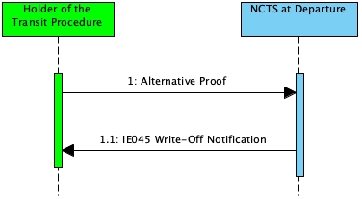

Figure 22: Manual closure at Departure based on alternative proof - Sequence Diagram

#### State Diagram

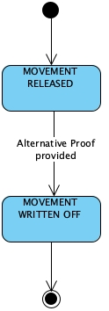

Figure 23: Manual closure at Departure based on alternative proof - State Diagram

#### Use Case Summary

The Holder of the Transit Procedure presents evidence that the transit movement has arrived at its final destination. The Office of Departure checks the alternative evidence and decides that the movement can be written off manually.

1. The Holder of the Transit Procedure selects the ‘Alternative Proof’ action and uploads documents that constitute the evidence that the transit movement has arrived at its final destination.
2. The Customs Officer checks the alternative evidence and decides that the movement can be written off manually
3. *The state of the movement is set to ‘Movement written off’*

### Diversion at Office of Destination

#### Sequence Diagram

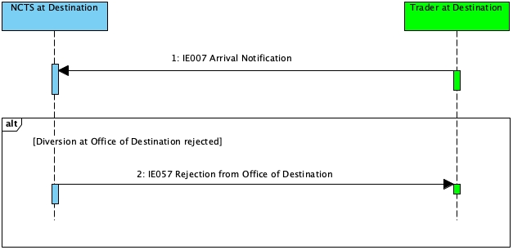

Figure 24: Diversion at Office of Destination - Sequence Diagram

#### Use Case Summary

**Core flow at Office of Destination - Diversion at Office of Destination accepted**

1. The Trader at Destination sends the ‘Arrival Notification’ (IE007) to the Actual Office of Destination
2. The message is syntactically valid
3. The message is logically valid
4. The diversion to this Actual Office of Destination is accepted
5. *The state of the movement at the Actual Office of Destination is set to ‘Arrival accepted’*

**Alternative Scenario: Diversion at Office of Destination rejected**

1. The diversion to this Actual Office of Destination is not accepted
2. *The state of the movement at the Actual Office of Destination is set to ‘Diversion rejected’*
3. The Office of Destination notifies the Trader at Destination with the ‘Rejection from Office of Destination’ (IE057) message

## Specific Scenarios for Incidents “En Route” (INC)

### Sequence Diagram

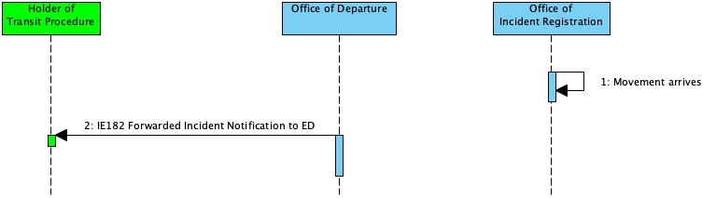

Figure 25: Incidents En Route - Capturing Movement Information - Sequence Diagram

### State Diagram

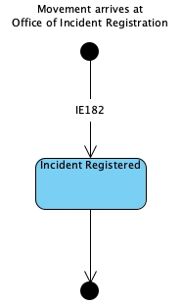

Figure 26: Incidents En Route - Capturing Movement Information - State Diagram

### Use Case Summary

**Incidents En Route - Capturing Movement Information**

1. The Carrier presents the goods and the MRN to the Office of Incident Registration
2. The Office of Departure forwards the incident information to the Holder of the Transit Procedure through the ‘Forwarded Incident Notification To ED’ (IE182) message
3. *The status at the Office of Incident Registration is set to Incident registered*

## Possible Exceptions in the Common Domain (EXC)

### Deviation from the Binding Itinerary at Actual Office of Transit - Movement is allowed Diversion after registering the Incident

#### Sequence Diagram

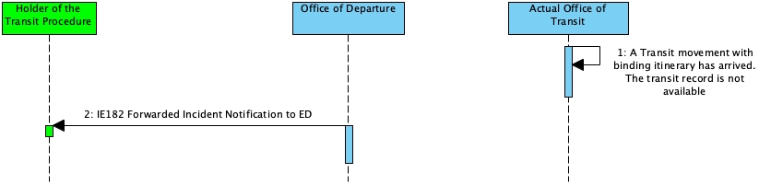

Figure 27: Deviation from Binding Itinerary at Actual Office of Transit - Sequence Diagram

#### State Diagram

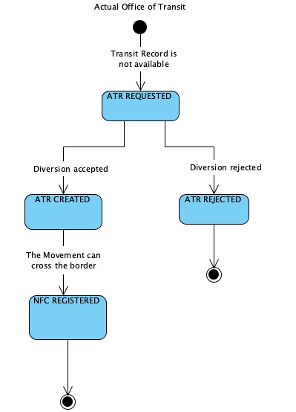

Figure 28: Deviation from Binding Itinerary at Actual Office of Transit - State Diagram

#### Use Case Summary

This scenario describes what happens when the transit movement is declared with binding itinerary, but for reasons beyond the carrier’s control, it is breached by arriving at a country that is not included into the list of countries of routing of consignment. The deviation of the transit movement from its binding itinerary must be treated as an incident.

##### Deviation from the Binding Itinerary at Actual Office of Transit

1. The transit movement is declared with binding itinerary and arrives at an Actual Transit Office
2. The transit record is not available at that Actual Office of Transit nor nationally. Additionally, as per declaration data, the country of this Actual Transit Office is not listed into the countries of routing of consignment and the flag ‘Binding Itinerary’ is equal to ‘1-Yes’).
3. The Actual Office of Transit requests the transit record from the Office of Departure
4. *The state of the movement at this Actual Office of Transit is set to ‘ATR Requested’*
5. The response to the request is negative
6. *The state of the movement at this Actual Office of Transit is set to ‘ATR Rejected’*
7. The incident is registered.
8. The Actual Office of Transit eventually allows the movement to cross its border
9. *The state of the movement at the Office of Transit is set to ‘NCF registered’*

##### Deviation from the Binding Itinerary at Office of Departure

1. The Office of Departure forwards the incident information to the Holder of the Transit Procedure through the ‘Forwarded Incident Notification To ED’ (IE182) message

## Export Followed by Transit (EFT)

The export followed by transit scenario is triggered when at least one (1) Export MRN is referenced in the transit declaration. Specifically, the Export MRNs should be declared by the Holder of the Transit Procedure into the Previous Document data group under the House Consignment data group of the transit declaration.

#### State Diagram

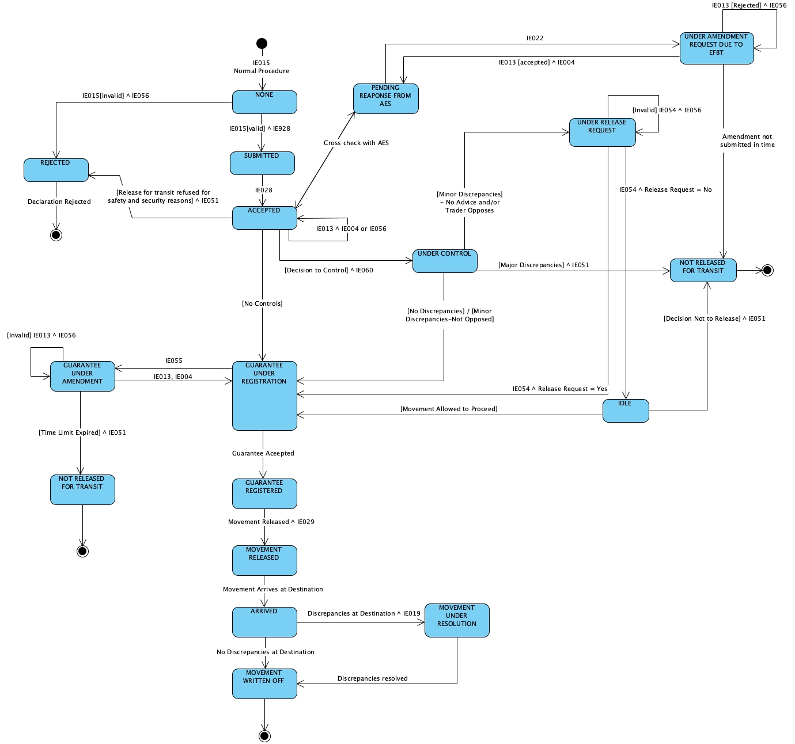

Figure 29: Export followed by Transit Office of Departure - State Diagram

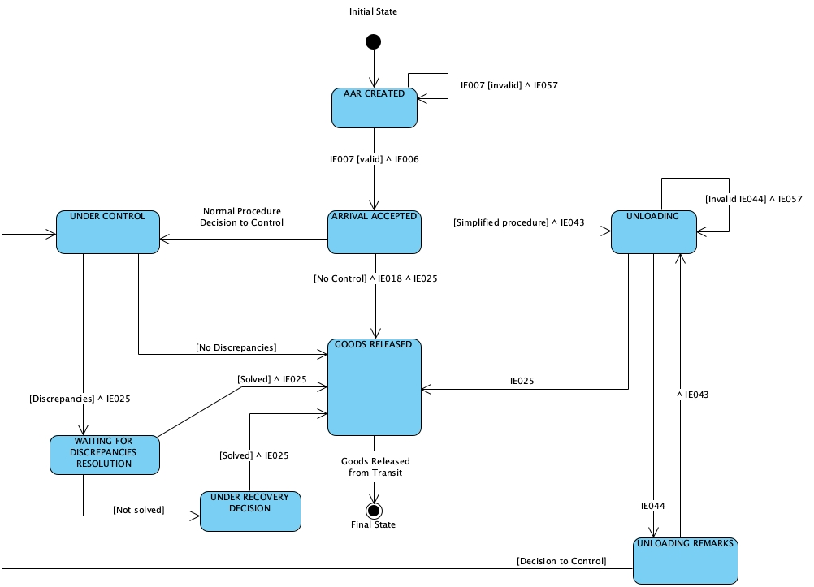

Figure 30: Export followed by Transit Office of Destination - State Diagram

### Export followed by transit - External transit

#### Sequence Diagram

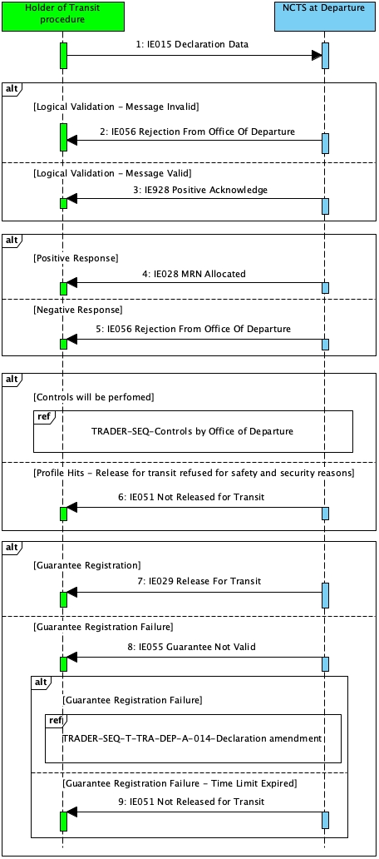

Figure 31: Export followed by Transit - External Transit - Sequence Diagram

#### Use Case Summary

**AES related part.**

1. The Declarant or Representative submits an Export Declaration to the Office of Export with the ‘Export Declaration’ (IE515) message. The Office of Export decides to release the export movement
2. The export movement arrives at the Office of Exit and thus the goods of the export movement are now located at the Office of Exit
3. The Declarant or Representative decides that the physical exit of goods from the Union Territory will be covered by the transit procedure
4. From this point, the Office of Exit will also possess the role of Office of Departure

**NCTS related part.**

1. The Holder of the Transit Procedure submits a transit declaration for external transit procedure by sending the ‘Declaration Data’ (IE015) message at the Office of Departure
2. The Transit declaration is syntactically valid
3. The transit declaration data contains references to Export MRNs in the previous documents (i.e. under the House Consignment data group)
4. The Transit declaration is logically valid

*Note*: The alternative flow where the Transit declaration is invalid is described in section ‘*3.1.1.3.1 Core flow at Office of Departure - Standard Transit Procedure Alternative flow - The Transit declaration is logically invalid - Rejection of transit declaration’*.

1. NCTS send the ‘Positive Acknowledge’ (IE928) message to the Holder of the Transit Procedure to acknowledge the reception of the transit declaration
2. *The state of the transit declaration at the Office of Departure is set to ‘Submitted’*
3. The Transit declaration is checked for the existence of the declared export MRN along with the state appropriateness at the Office of Exit in the AES system.
4. The cross check produces positive results. The alternative flows for the negative responses are described in the following sections:
   * *3.6.2.2.1 Lodgement of transit declaration having export as previous procedure - Negative response from Office of Exit (before acceptance)*
   * *3.6.2.2.2 Lodgement of Transit Declaration having Export as Previous Procedure - Unknown Export MRN and Positive response from Office of* Exit (before acceptance)
5. If an ARC is included in the response from the Office of Exit, NCTS verifies this against IE015 data
6. The ARC reference number(s) (or fallback e-AD(s)) is/are included in the ‘Declaration Data’ (IE015)

The alternative flow is described in section ‘*3.6.2.2.3 Lodgement of transit declaration having export as previous procedure (external transit) - ARC Reference Number (or fallback e-AD reference number) as exists in Export Declaration data does not match with Transit Declaration Data’*

1. NCTS accepts the transit declaration
2. NCTS communicates the MRN to the Holder of the Transit Procedure with the ‘MRN Allocated’ (IE028) message
3. *The state of the movement at the Office of Departure is set to ‘Accepted’*
4. NCTS informs the Office of Exit to allocate the transit MRN for the Export MRNs, since the transit declaration has been accepted
5. *The state of the movement at the Office of Departure is set to ‘Pending response from AES’*
6. NCTS receives a positive response for the successful allocation of the Transit MRN with the Export MRN(s)

*Note: The alternative scenario is described in section ‘3.6.2.2.4 Transit movement having export as previous procedure is not released for transit’*

1. *The state of the movement at the Office of Departure is set to ‘Accepted’*
2. Risk analysis has been performed and no controls are required
3. *The state of the movement at the Office of Departure is set to ‘Under guarantee registration’*
4. When all guarantees are registered,
5. *The state of the movement at the Office of Departure is set to ‘Guarantee registered’*
6. NCTS decides to release the movement
7. *The state of the movement at the Office of Departure is set to ‘Movement released’*
8. NCTS sends the ‘Release for transit’ (IE029) message to the Holder of the Transit Procedure.

The business flow of the transit procedure continues with the arrival of the transit movement at the final Office of Destination as described in section ‘*3.1.1 Standard Transit Procedure (overview)’*

##### Lodgement of transit declaration having export as previous procedure - Negative response from Office of Exit (before acceptance)

1. One (1) or more of the Export MRNs declared in the Transit Declaration exists, but it is not in appropriate status at the Office of Exit
2. NCTS rejects the Transit Declaration and notifies the Holder of the Transit Procedure with the ‘Rejection from Office of Departure’ (IE056) message
3. *The state is set to ‘Rejected’*
4. This status is final

The business flow of the transit procedure ends here. The export movement can continue as previous procedure in another new transit declaration or proceed with another Office Exit business process.

##### Lodgement of Transit Declaration having Export as Previous Procedure - Unknown Export MRN and Positive response from Office of Exit (before acceptance)

1. One (1) or more of the Export MRNs declared in the Transit Declaration does not exist at the Office of Exit. The missing Export MRN information must be collected
2. *The state of the movement at the Office of Departure is set to ‘Pending response from AES’*
3. NCTS collects the missing information
4. *The state of the transit movement at the Office of Departure is set to ‘Accepted’*

The process continues as described in section ‘*3.1.1 Standard Transit Procedure (overview)’*

##### Lodgement of transit declaration having export as previous procedure (external transit) - ARC Reference Number (or fallback e-AD reference number) as exists in Export Declaration data does not match with Transit Declaration Data

The Holder of the Transit procedure lodges a transit declaration at the Office of Departure that references Export MRNs in the previous documents (under House Consignment data group). However, no or different ARC reference number(s) (or the fallback e-AD reference number(s)) is/are provided in the ‘Declaration Data’ (IE015) (under the DG HOUSE CONSIGNMENT-CONSIGNMENT ITEM-ADDITIONAL REFERENCE) compared to the ARC Reference number(s) included in the Export Declaration. Therefore, this scenario examines this case where the transit movement is accepted but it is automatically set under control due to the minor discrepancy in the ARC reference number(s) between the Transit and Export Declarations.

1. Some or all of the ARC reference number(s) (or the fallback e-AD reference number(s)) does not verify with those included in the ‘Declaration Data’ (IE015) [under the under the DG HOUSE CONSIGNMENT-CONSIGNMENT ITEM-ADDITIONAL REFERENCE]

*Note:*

*NCTS verifies if the ARC reference number(s) is/are also included in the IE015 (by checking) the Supporting Document field for T2 goods or Additional Reference field for T1 contains Type C651 or C658 and (ARC) Ref Numbers. After verifying that the ARC reference number(s) (or fallback eAD(s)) is/are included in the IE015, NCTS accepts the transit declaration and communicates the MRN to the Holder of the Transit procedure.*

1. NCTS accepts the transit declaration and communicates the MRN to the Holder of the Transit Procedure with the ‘MRN Allocated’ (IE028) message.
2. *The state of the movement at the Office of Departure is set to Accepted*
3. NCTS communicates with the Office of Exit to allocate the transit MRN for the Export MRNs, since the transit declaration has been accepted
4. *The state of the movement at the Office of Departure is set to ‘Pending response from AES’*
5. The allocation of the Transit MRN with the Export MRN(s) is successful
6. *The state of the movement at the Office of Departure is set to ‘Accepted’*
7. No or different ARC reference number(s) (or the fallback e-AD reference number(s)) is/are provided in the ‘Declaration Data’ (IE015) (under the DG HOUSE CONSIGNMENT-CONSIGNMENT ITEM-ADDITIONAL REFERENCE) compared to the ARC Reference number(s) included in the Export Declaration
8. NCTS sends the ‘Control Decision Notification’ (IE060) message to the Holder of the Transit Procedure in order to notify about the upcoming control activities (having the data element TRANSIT OPERATION-Notification type = ‘0-Decision to Control (and requested documents if needed)’). This message is sent in both cases of Normal and Simplified Procedures.
9. *The state of the movement at the Office of Departure is set to ‘Under control’*
10. The results of the control activity indicate minor discrepancies due to the difference in ARC reference number(s) (or the fallback e-AD reference number(s)) between the Export and the Transit Declarations.
11. Advice is needed from the Holder of the Transit Procedure.
12. *The status of the movement at the Office of Departure is set to ‘Under release request’*
13. NCTS send to the Holder of the Transit Procedure the ‘Request for Advice’ (TR054) message to request the lodgement of an ‘Request of Release’ (IE054) message
14. The Holder of the Transit Procedure sends the ‘Request of Release’ (IE054), containing the flag ‘Release Request’ set to “1-Yes”, to NCTS meaning that the Holder of the Transit Procedure does not oppose the minor discrepancies in the ARC reference numbers to be aligned in the transit declaration with those of the export declaration

*Note: In case the Holder of the Transit Procedure opposes the minor discrepancies due to no or different ARC reference number(s) between the Transit and Export Declarations, please refer to the scenario ‘Negative release request’, where the case that NCTS does not allow the transit movement to be released for transit is also described.*

1. *The state of the movement at the Office of Departure is set to ‘Under guarantee registration’*

The transit procedure continues as described in section ‘*3.6.2 Export followed by transit - External transit*’

##### Transit movement having export as previous procedure is not released for transit

This scenario describes what happens when the transit declaration that references Export MRNs into its previous documents is not released for transit.

1. *The state of the transit movement at the Office of Departure is under ‘Accepted’*
2. NCTS decides not to release the transit movement for transit
3. *The state at the Office of Departure is set to ‘Not released for transit’*
4. NCTS sends the ‘No Release for Transit’ (IE051) message to the Holder of the Transit Procedure.

The business process of the transit procedure ends here.

*Note:*

The circumstances where the NCTS will decide not to release the movement are:

* Control by Office of Departure with release for transit refused
* Where a transit goes under control and the OofDep finds a major discrepancy/the goods pose a threat to Safety and Security, then the OoDep does not release for transit and informs the HTP by sending IE051 ‘No release for Transit’ message
* Release for transit refused due to guarantee registration failure
* The HTP fails to send the declaration amendment message IE013 before the Guarantee Awaiting Amendment timer expires, then the movement is not released and a IE051 (No Release for Transit) message is automatically sent by the system to the HTP

### Export followed by transit - Internal transit

#### Sequence Diagram

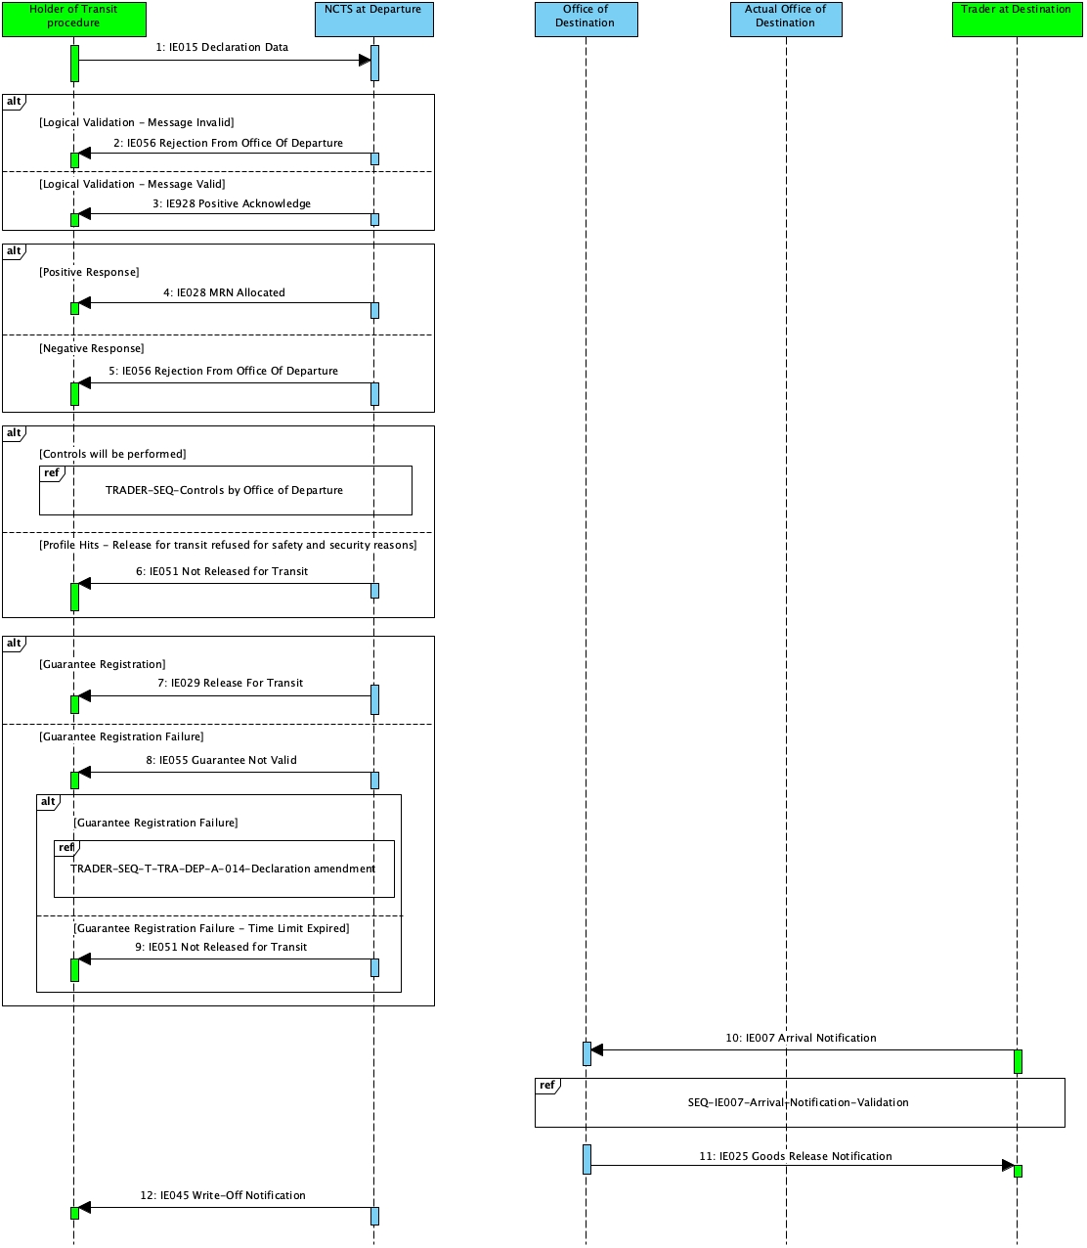

Figure 32: Export followed by Transit - Internal Transit - Sequence Diagram

#### Use Case Summary

##### Appropriate Office of Destination

This scenario depicts the case that the Holder of the Transit Procedure submits the ‘Declaration Data’ (IE015) message to the Office of Departure that contains an appropriate Declared Office of Destination, and the transit movement arrives at this Declared Office of Destination.

**AES related part.**

1. The Declarant or Representative submits an Export Declaration to the Office of Export with the ‘Export Declaration’ (IE515) message. The Office of Export decides to release the export movement
2. The export movement arrives at the Office of Exit and thus the goods of the export movement are now located at the Office of Exit
3. The Declarant or Representative decides that the physical exit of goods from the Union Territory will be covered by the transit procedure
4. From this point, the Office of Exit will also possess the role of Office of Departure

###### Office of Departure

1. The Holder of the Transit Procedure submits a transit declaration for internal transit procedure by sending the ‘Declaration Data’ (IE015) message
2. The Transit declaration is syntactically valid
3. The transit declaration data contains references to Export MRNs in the previous documents (i.e. under the House Consignment data group)
4. The Transit declaration is logically valid

* ‘Appropriateness’ of the Office of Destination since the transit movement is under internal transit - i.e. the Office of Destination either belongs to an EU MS and possesses the role ‘EXT-Office of Exit’ or the Office of Destination belongs to a CTC country.

1. NCTS acknowledges the reception of the transit declaration with the ‘Positive Acknowledge’ (IE928) message
2. *The transit declaration is set to the status ‘Submitted’*
3. NCTS sends the transit declaration to the Office of Exit for cross-check so as to perform an initial validation

*Note*: This initial validation comprises the existence of the declared export MRN along with the state appropriateness at the Office of Exit in the AES system. In case of Simplified Procedure, the location of goods as specified in the Authorization of Authorized Consignor (ACR) is also validated.

1. The initial cross check is successful
2. NCTS accepts the transit declaration and communicates the MRN to the Holder of the Transit Procedure with the ‘MRN Allocated’ (IE028) message
3. *The state of the movement at the Office of Departure is set to ‘Accepted’*
4. NCTS communicates with AES to allocate the transit MRN for the Export MRNs since the transit declaration is accepted
5. *The state of the movement at the Office of Departure is set to ‘Pending response from AES’*
6. The allocation of the Transit MRN with the Export MRN(s) is successful

*Note:* The alternative scenario is described in section ‘*3.6.2.2.4 Transit movement having export as previous procedure is not released for transit*’

1. *The state of the movement at the Office of Departure is set to ‘Accepted’*
2. Risk analysis has been performed and no controls are required.
3. *The state of the movement at the Office of Departure is set to ‘Under guarantee registration’*
4. NCTS registers the guarantees
5. *The state of the movement at the Office of Departure is set to ‘Guarantee registered’*
6. NCTS decides to release the movement
7. NCTS sends the ‘Release for Transit’ (IE029) message to the Holder of the Transit Procedure.
8. *The state of the movement at the Office of Departure is set to ‘Movement released’*
9. The movement has left the Security Area
10. The movement arrived and crossed the borders
11. *The state of the movement at the Office of Departure remains ‘Movement released*
12. The movement has arrived at its final destination
13. *The state of the movement at the Office of Departure is set to ‘**Arrived**’*
14. NCTS validates that the Office of Destination is appropriate (i.e. possesses either the role ‘EXT-Office of Exit’ or belongs to a CTC country).
15. The control results at destination are satisfactory
16. NCTS sends the ‘Write-Off Notification’ (IE045) message to the Holder of the Transit Procedure.

The business flow of the transit procedure ends here.

###### Office of Destination

1. The Trader at Destination sends the ‘Arrival Notification’ (IE007) message to notify the Office of Destination that the movement has arrived at the Office of Destination
2. The message is syntactically valid
3. The message is logically valid
4. *The state of the movement at the Office of Destination is set to ‘Arrival accepted’*
5. NCTS decided to release the goods
6. *The state of the movement at the Office of Destination is set to ‘**Goods released*’
7. NCTS notifies the Trader at Destination with the ‘Goods Release Notification’ (IE025) message (i.e. “Release Indicator” flag is equal to “1-Full release of goods (as per declaration) - Movement closed”).

##### Inappropriate Office of Destination

This scenario depicts the case that the Holder of the Transit Procedure submits the ‘Declaration Data’ (IE015) message to the Office of Departure that even though it contains an appropriate Declared Office of Destination, the transit movement arrives to an inappropriate Actual Office of Destination.

###### Office of Destination

1. The movement arrives at destination
2. The Trader at Destination sends the ‘Arrival Notification’ (IE007) message to an Actual Office of Destination to notify for the arrival of the movement
3. The declaration information is not available at the office of Destination
4. NCTS requests the declaration information from the Office of Departure
5. NCTS receives the declaration information
6. The movement arrives at its final destination
7. *The state of the movement at the Office of Destination is set to ‘Arrival accepted’*

The business flow of the transit procedure continues as of the Standard Transit Procedure.

### Amendment of transit declaration having export as previous procedure

#### Sequence Diagram

Figure 33: Amendment of transit declaration having export as previous procedure - Sequence Diagram

#### Use Case Summary

##### Amendment of transit declaration having export as previous procedure – Positive Response from AES

This scenario examines what happens when the AES replies with positive response to the NCTS following amendment of the transit declaration altering Export MRNs referenced in the transit declaration (i.e. after valid amendment request submitted by the Holder of the Transit Procedure) or when due to amendment of the transit declaration, the Office of Exit receives an invalidation notification to de-allocate all Export MRNs.

This scenario starts either with:

* Export followed by transit - External transit; or
* Export followed by transit - Internal transit

1. *The state of the transit movement at the Office of Departure is ‘Accepted’*
2. The Holder of the Transit Procedure submits a ‘Declaration Amendment’ (IE013) message to the Office of Departure
3. The message is syntactically valid
4. NCTS validates the amendment request sent by the Holder of the Transit Procedure
5. The request is valid
6. NCTS communicates the acceptance with the ‘Amendment Acceptance’ (IE004) message
7. *The state of the transit movement at the Office of Departure remains ‘Accepted’*
8. NCTS verifies that changes are made into the Export MRNs under the Previous Document data group(s) due to the submitted amendment requested by the Holder of the Transit Procedure (i.e. added/updated/deleted Export MRNs).

**CASE A: At least one (1) Export MRN is present after amendment**

1. Changes have been made in the Export MRNs, but at least one (1) Export MRN still remains present in the transit declaration after amendment of the transit declaration, NCTS cross checks with AES
2. *The state of the transit movement at the Office of Departure is set to ‘Pending response from AES’*
3. The results of the cross check are positive
4. *The state of the transit movement at the Office of Departure is set to ‘Accepted’*
5. The process continues regularly from the same step after the acceptance of the transit movement:

* Export followed by transit - External transit; or
* Export followed by transit - Internal transit

**CASE B: No Export MRN is present after amendment**

**Step-13.**

1. Changes have been made in the Export MRNs by removing all Export MRNs from the transit declaration after amendment
2. *The state of the transit movement at the Office of Departure is set to ‘Accepted’*
3. The process continues regularly for the transit movement without having Export MRNs as previous procedure(s) with *3.2.2 Amendment of Transit Declaration*.

##### Amendment of transit declaration having export as previous procedure – Negative Response from AES

This scenario examines what happens when a negative response is returned from AES due to the amendment of the Export MRNs referenced in the transit declaration as requested by the Holder of the Transit Procedure. In that case, NCTS notifies the Holder of the Transit Procedure with the ‘Notification to Amend Declaration’ (IE022) message to submit an updated amendment request. This is a mandatory next step for the Holder of the Transit Procedure.

This scenario starts either with:

* Export followed by transit - External transit; or
* Export followed by transit - Internal transit

1. *The state of the transit movement at the Office of Departure is ‘Accepted’*
2. The Holder of the Transit Procedure submits a ‘Declaration Amendment’ (IE013) message to the Office of Departure.
3. The Amendment is syntactically valid
4. NCTS validates the amendment request
5. The request is valid
6. NCTS communicates its acceptance with the ‘Amendment Acceptance’ (IE004) message
7. *The state of the transit movement at the Office of Departure is still under ‘Accepted’*
8. NCTS verifies that changes to the Export MRNs exist to the Previous Document data group(s) due to the amendment from the Holder of the Transit Procedure (i.e. added/updated/deleted Export MRNs).
9. Changes have been made in the Export MRNs, and NCTS cross checks with AES
10. The cross check is successful
11. *The state of the transit movement at the Office of Departure is set to ‘Pending response from AES’*
12. The amendment request validation at AES fails (e.g. the Export MRNs are under an inappropriate status at the Office of Exit)
13. NCTS receives a negative response
14. *The state of the movement at the Office of Departure is set to ‘Under amendment request due to EFBT’*
15. NCTS notifies the Holder of the Transit Procedure with the ‘Notification to Amend Declaration’ (IE022) message

***Note*:**

If the Holder of Transit Procedure does not submit such an amendment on time then *The status of the transit declaration will be set to ‘Not released for transit’*

1. The Holder of the Transit Procedure submits another ‘Declaration Amendment’ (IE013) message to the Office of Departure
2. NCTS validates (i.e. in terms of message structure and R/Cs) the amendment request sent by the Holder of the Transit Procedure
3. The request is valid
4. NCTS communicates its acceptance with the ‘Amendment Acceptance’ (IE004) message
5. The cross check with AES fails
6. The Holder needs to submit again a new ‘Declaration Amendment’ (IE013) message
7. *The state is set to ‘Under amendment request due to EFBT’*
8. The process repeats from [Step 15] above
9. The cross check with AES is successful
10. The process continues regularly from the step after the acceptance of the transit movement:

* Export followed by transit - External transit; or
* Export followed by transit - Internal transit

### Transit movement having export as previous procedure - Control results from destination indicate major discrepancies

#### Sequence Diagram

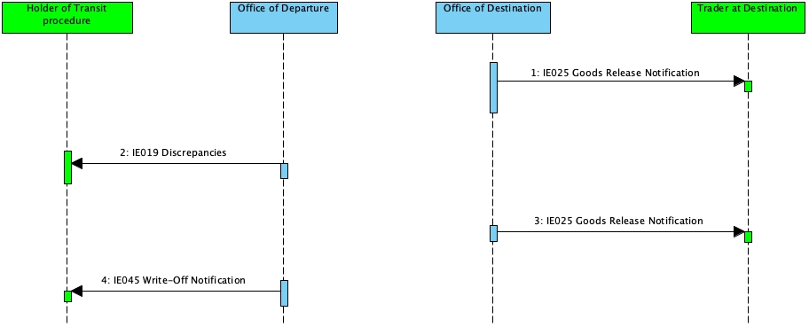

Figure 34: Control results from destination indicate major discrepancies - Sequence Diagram

#### State Diagram



Figure 35: Control results from destination indicate major discrepancies - State Diagram

#### Use Case Summary

This scenario starts as of Core flow of the export followed by transit - Internal transit (Appropriate Office of Destination).

#### NCTS at Destination

Following control by the Office of Destination, unsatisfactory control results are reported into the transit movement that contains Export MRN(s) as previous documents

1. NCTS sends the ‘Goods Release Notification’ (IE025) message to the Trader at Destination in order to notify them that the transit procedure has not ended correctly due to the existence of major discrepancies in the destination’s control results (i.e. Release indicator is NOT equal to ‘1- Full release of goods (as per declaration) - Movement closed’)
2. *The state of the movement at the Office of Destination is set to ‘Waiting for discrepancies resolution’*
3. Τhe discrepancies are resolved
4. *The state of the movement at the Office of Destination is set to ‘Goods released’*
5. NCTS sends the ‘Goods Release Notification’ (IE025) message to the Trader at Destination in order to notify them that the transit procedure has ended successfully, and for instance all the goods can be released from transit (i.e. Release indicator is equal to ‘1- Full release of goods (as per declaration) - Movement closed’)

#### NCTS at Departure

1. The control results code indicates major discrepancies ‘B1’
2. *The state of the movement at the Office of Departure is set to Movement under resolution*
3. NCTS sends to the Holder of the Transit Procedure the ‘Discrepancies’ (IE019) message informing him that there are major discrepancies in the destination control results
4. Τhe major discrepancies of the destination control results are resolved
5. *The state of the movement at the Office of Departure is set to ‘Movement written off’*
6. NCTS sends the ‘Write-Off Notification’ (IE045) message to the Holder of the Transit Procedure

The business process of the transit procedure ends here.

### Transit movement having export as previous procedure - Departure notifies Office of Exit for the initiation of Recovery

#### Sequence Diagram

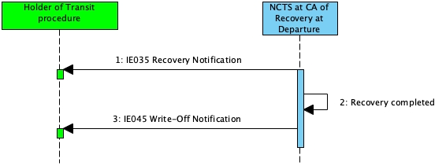

Figure 36: Initiation of Recovery of transit declaration having export as previous procedure - Sequence Diagram

#### State Diagram

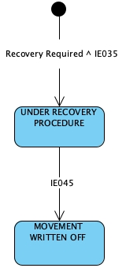

Figure 37: Initiation of Recovery of transit declaration having export as previous procedure - State Diagram

#### Use Case Summary

1. Recovery is decided to be performed by the Competent Authority of Recovery at Departure
2. *The status of the transit movement at the Competent Authority of Recovery at Departure is set to ‘Under recovery procedure’*
3. The Competent Authority of Recovery at Departure sends the ‘Recovery Notification’ (IE035) message to the Holder of the Transit Procedure
4. The Competent Authority of Recovery at Departure completes Recovery
5. The ‘Write-off Notification’ (IE045) message is sent to the Holder of the Transit Procedure
6. *The state of the movement at the Office of Departure is set to ‘Movement written off’*

The business process of the transit procedure ends here.

### Manual closure at Departure based on alternative proof - Export is previous procedure

#### Sequence Diagram

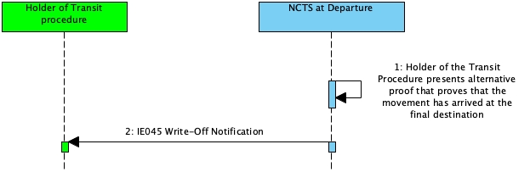

Figure 38: Closure based on alternative proof - Sequence Diagram

#### State Diagram

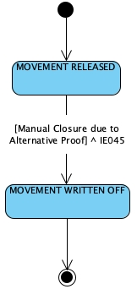

Figure 39: Closure based on alternative proof - State Diagram

#### Use Case Summary

The Holder of the Transit Procedure presents alternative proof that proves that the movement has arrived at the final destination.

1. *The state of the movement at the Office of Departure is ‘Movement Released’*
2. The Holder of the Transit Procedure presents alternative proof that proves that the movement has arrived at the final destination
3. NCTS examines the proof and decides to accept the proof and close the movement
4. NCTS sends the ‘Write-off Notification’ (IE045) message to the Holder of the Transit Procedure
5. *The state of the movement at the Office of Departure is ‘Movement Written Off’*

The business process of the transit procedure ends here.

### Invalidation of transit declaration having export as previous procedure - Before release for transit

#### Sequence Diagram

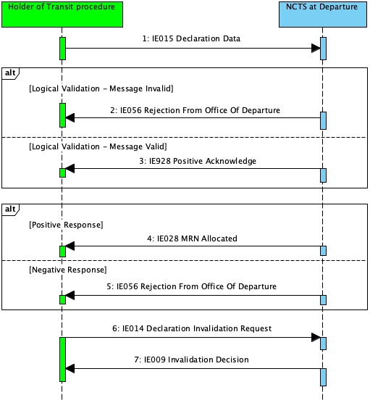

Figure 40: Invalidation of transit declaration having export as previous procedure - Sequence Diagram

#### State Diagram

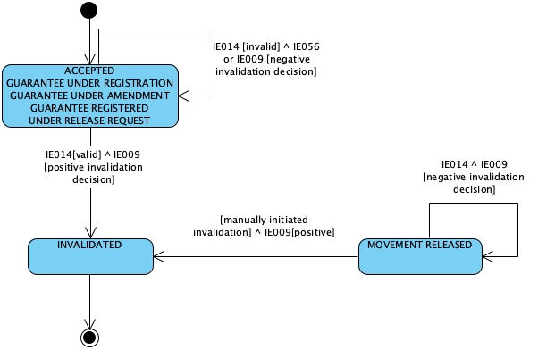

Figure 41: Invalidation of transit declaration having export as previous procedure - State Diagram

#### Use Case Summary

This scenario starts either with:

* Export followed by transit - External transit;

or

* Export followed by transit - Internal transit

1. *The state of the transit movement at the Office of Departure is under ‘Accepted’*
2. The Holder of the Transit Procedure submits a ‘Declaration Invalidation Request’ (IE014) message
3. NCTS examines the invalidation request submitted by the Holder of the Transit Procedure and decides to accept it
4. NCTS sends to the Holder of the Transit Procedure a positive ‘Invalidation Decision’ (IE009) message
5. *The state of the movement at the Office of Departure is set to ‘Invalidated’*
6. Τhe Transit MRN are de-associated from the Export MRNs. That way, the Export MRNs become available for another procedure.

The business process of the transit procedure ends here

**Alternative scenario – Invalidation request rejected**

This scenario starts either with:

* Export followed by transit - External transit;

or

* Export followed by transit - Internal transit

1. *The state of the transit movement at the Office of Departure is under ‘Accepted’*
2. The Holder of the Transit Procedure submits a ‘Declaration Invalidation Request’ (IE014) message
3. NCTS examines the invalidation request submitted by the Holder of the Transit Procedure and decides to reject it
4. NCTS sends to the Holder of the Transit Procedure a negative ‘Invalidation Decision’ (IE009) message
5. *The state of the movement at the Office of Departure remains ‘Accepted’*

## NCTS GUARANTEE MANAGEMENT (GMN)

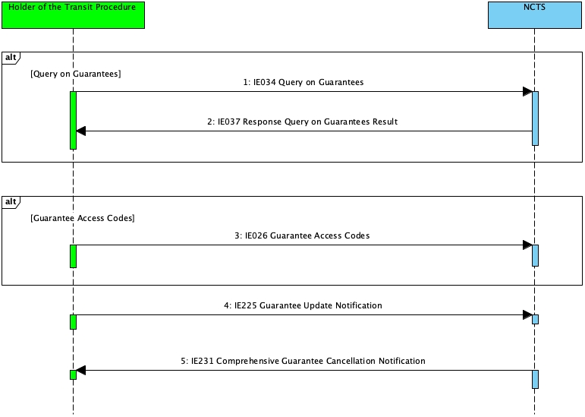

Figure 42: Information exchange for Guarantee management - Overview

### Guarantee Access Codes

The Holder of Transit procedure may assign (re-assign) one or more guarantee access codes to one of their own guarantees by communicating the IE026 ‘Guarantee Access Codes’ to NCTS.

### Guarantee Update Notification

When NCTS registers the comprehensive guarantee data, the updated guarantee data are communicated to the Holder of Transit procedure with the IE225 ‘Guarantee Update Notification’ message.

### Comprehensive Guarantee Cancellation Notification

When NCTS cancels a comprehensive guarantee, the Holder of Transit procedure is informed about the cancelled comprehensive guarantee by NCTS with the IE231 ‘Comprehensive Guarantee Cancellation Notification’.

### Check Guarantee Integrity (GUI)

#### Check guarantee integrity

##### Sequence Diagram

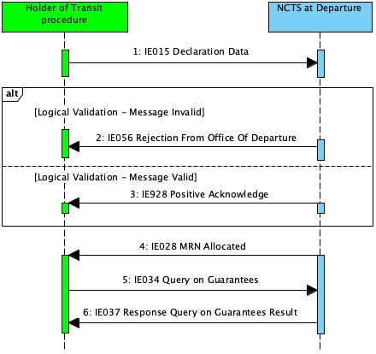

Figure 43: Check guarantee integrity - Sequence Diagram

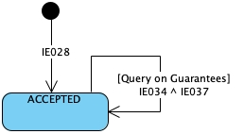

Figure 44: Check guarantee integrity - State Diagram

##### Use Case Summary

The scenario starts after receiving the ‘MRN Allocated’ (IE028) message and the state of the movement is set to “Accepted”.

1. The Holder of the Transit Procedure send the ‘Query on Guarantees’ (IE034) message to NCTS
2. NCTS sends to the Holder of the Transit Procedure the ‘Response Query on Guarantees Result’ (IE037)

### Guarantor message exchanges

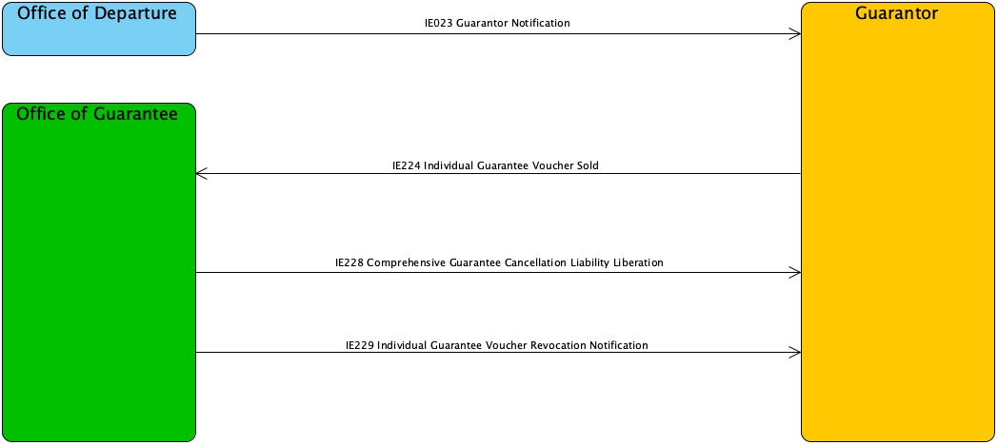

Figure 45: Information Exchange involving the Guarantor

* IE023 ‘Guarantor Notification’: When the recovery procedure is initiated, the Office of Departure will automatically inform the Guarantor about the start of the Recovery Procedure
* IE224 ‘Individual Guarantee Voucher Sold’: The Guarantor must inform (IE224) the Office of Guarantee (at which the concerned individual guarantee in the form of vouchers document is lodged) about the sold individual guarantee voucher(s)
* IE228 ‘Comprehensive Guarantee Cancellation Liability Liberation’: If no more movements are covered by the cancelled comprehensive guarantee (when all the movements are ‘written off’), the liability of the Guarantor (related to a cancelled comprehensive guarantee) is released and the Guarantor is informed by the Office of Guarantee
* IE229 ‘Individual Guarantee Voucher Revocation Notification’: The revocation of the individual guarantee in the form of vouchers is communicated to the Guarantor by the Office of Guarantee;

## NCTS HANDLE ENQUIRY & RECOVERY

The Enquiry process is initiated by the Competent Authority of Enquiry at Departure to investigate the non-arrived movement within the expected time.

After the initiation of Enquiry, the Competent Authority of Enquiry at Departure verifies that the information on the Consignee is not sufficient. Therefore, it sends the ‘Request on a Non-Arrived Movement’ to the Holder of the Transit Procedure. If the Holder of the Transit Procedure provides negative response or no response, Recovery is recommended, although it does not exclude that the Competent Authority of Enquiry at Departure, instead of starting Recovery, may continue Enquiry with the Competent Authority of Enquiry at Destination by sending the ‘Enquiry Request’. Each time the decision is taken by the Competent Authority of Enquiry at Departure.

### Enquiry

#### Sequence Diagram

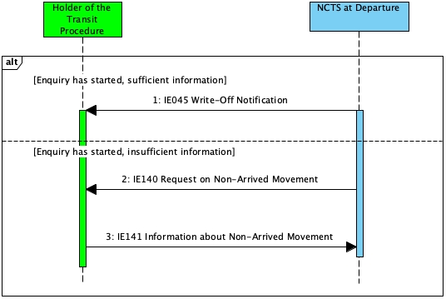

Figure 46: Enquiry - Sequence Diagram

#### State Diagram



Figure 47: Enquiry - State Diagram

#### Use Case Summary

* 1. The Enquiry procedure has started, sufficient information for the discharge of the transit procedure

1. *The state of the movement is set to ‘Under enquiry procedure’*
2. The movement is written-off
3. NCTS sends the ‘Written-off Notification’ (IE045) message to the Holder of the Transit Procedure.
4. *The state of the movement is set to ‘Movement written off’*
   1. The Enquiry procedure has started, insufficient information for the discharge of the transit procedure
5. *The state of the movement is set to ‘Under enquiry procedure’*
6. NCTS sends the ‘Request on Non-Arrived Movement’ (IE140) message to the Holder of the Transit Procedure
7. The Holder of the Transit Procedure sends the ‘Information about Non-Arrived Movement’ (IE141) message
8. The movement is written-off
9. *The state of the movement is set to ‘Movement written off’*

If the information provided by the Holder of the Transit Procedure is negative, then the recovery procedure will be initiated.

### Recovery

The Recovery procedure usually starts as a follow up to the Enquiry procedure. The Recovery can be initiated if the goods never arrive at any Office of Destination, or alternatively when the goods have arrived, but major discrepancies have been identified by the Customs Office of Destination.

#### Sequence Diagram

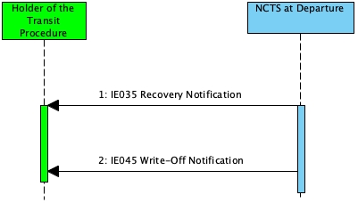

Figure 48: Recovery - Sequence Diagram

#### State Diagram

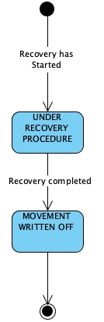

Figure 49: Recovery - State Diagram

#### Use Case Summary

The Recovery procedure has started.

1. *The state of the movement is set to ‘Under recovery procedure’*
2. NCTS sends the ‘Recovery Notification’ (IE035) message to the Holder of the Transit Procedure
3. NCTS sends the Write-off Notification’ (IE045) message to the Holder of the Transit Procedure
4. *The state of the movement is set to ‘Movement written off’*

## Controls

### Controls at Office of Departure

#### Sequence Diagram

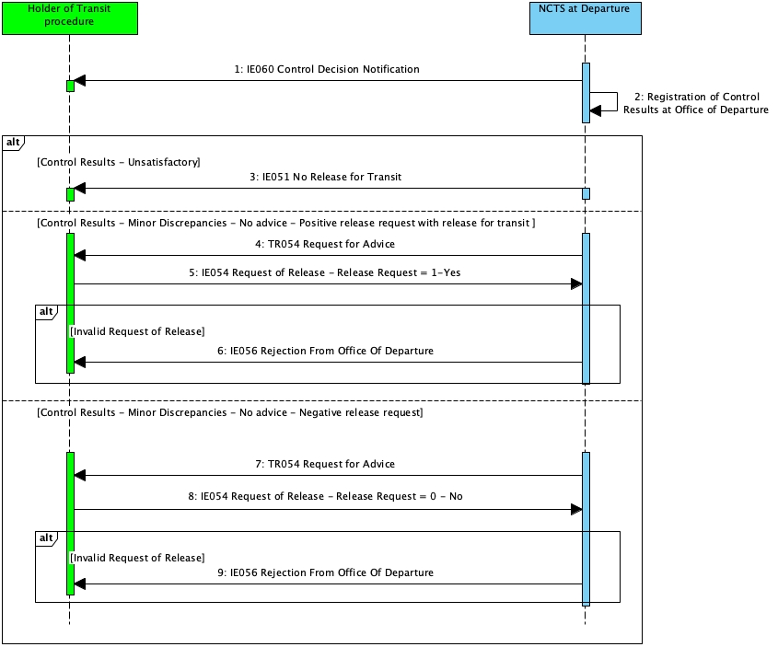

Figure 50: Controls at Office of Departure - Sequence Diagram

3.11.1.2 State Diagram

N/A

#### Use Case Summary

1. The Office of Departure decides to control the transit movement
2. NCTS sends the ‘Control Decision Notification’ (IE060) message to the Holder of the Transit Procedure to notify about the upcoming control activities (having the data element TRANSIT OPERATION-Notification type = ‘0-Decision to Control (and requested documents if needed)’)
3. *The state of the movement at the Office of Departure is set to “Under control”*
4. The results of the control activity are registered in NCTS

The business flow of the transit procedure may continue with one (1) of the following alternatives:

* Control results at the Office of Departure are satisfactory: in that case, the business flow continues as in *3.1.1 Standard Transit Procedure (overview)*
* Control results at the Office of Departure show minor discrepancies (not opposed by Holder of the Transit Procedure): the business flow continues as in  *3.1.1 Standard Transit Procedure (overview)*
* Control results at the Office of Departure show minor discrepancies (Holder of the Transit Procedure does not provide advice and/or opposes these minor discrepancies): please refer to: *(3.9.1.2.1 Minor Discrepancies found during Control)*
* Control results at the Office of Departure are unsatisfactory: in that case,
* NCTS sends to the Holder of the Transit Procedure the ‘No Release for Transit’ (IE051) message
* *The state of the transit operation is set to ‘Not released for Transit’*
* This is a final state.

##### Minor Discrepancies found during Control

If Control reveal minor discrepancies, the Holder of the Transit Procedure needs to provide their advice on the proposed revision(s) for these minor discrepancies.

###### The Holder of the Procedure gives the advice right away

1. The Holder of the Transit Procedure accepts the revisions in the transit declaration
2. The Office of Departure revises the declaration data based on the results of control and the ‘Satisfactory’ control results code is registered
3. After calculation of the duties and taxes the process continues with the registration of the guarantee usage.

###### The Holder of the Transit Procedure does not provide any advice right away after the control

**Positive release request with release for transit**

1. The results of the control activity indicate minor discrepancies and advice is needed from the Holder of the Transit Procedure
2. The ‘Minor Discrepancies Found During Control’ flow will be executed (see below)
3. The Holder of the Transit Procedure does not provide advice immediately
4. *The status of the movement at the Office of Departure is set to “Under release request”*
5. The Holder of the Transit Procedure sends the ‘Request of Release’ (IE054) to the Office of Departure
6. The 'Request of Release' (IE054) message is valid
7. The IE054 contains the flag ‘Release Request’ set to “1-Yes” (i.e. the Holder of the Transit Procedure has accepted the revisions - No opposition on minor revisions)
8. *The state of the movement is set to “Guarantee under registration”*
9. The business flow of the transit procedure continues as of Standard Transit Procedure *(3.1 Core Flow (CFL))*

**Negative release request**

1. The results of the control activity indicate minor discrepancies and advice is needed from the Holder of the Transit Procedure
2. The ‘Minor Discrepancies Found During Control’ flow will be executed (see below)
3. The Holder of the Transit Procedure does not provide advice immediately
4. *The status of the movement at the Office of Departure is set to “Under release request”*
5. The Holder of the Transit Procedure sends the ‘Request of Release’ (IE054) to the Office of Departure
6. The 'Request of Release' (IE054) message is valid
7. The IE054 contains the flag ‘Release Request’ set to “0-No” (i.e. the Holder of the Transit Procedure has rejected the discrepancies - Opposition on minor revisions)
8. *The state of the movement is set to “Idle”*
9. The Office of Departure has to make the final decision whether to release or not the movement for transit. The business flow of the transit procedure can continue with one (1) of the following two (2) alternatives:

* In case the Office of Departure decides to allow the movement to proceed towards release for transit despite the fact that there are minor discrepancies, the business flow continues as of Standard Transit Procedure *(3.1 Core Flow (CFL))*
* In case the Office of Departure reaches a no release decision, the Office of Departure will inform the Holder of the Transit Procedure by sending the ‘No Release for Transit’ (IE051) message. *The state of the transit operation is set to Not released for Transit*. This is a final state.

**Minor Discrepancies Found During Control**

When discrepancies are discovered while a movement is under control, the Holder of the Transit Procedure will be requested to amend the declaration. Additionally, the system will cover the following scenario:

1. The Control Officer closes the Control Case with minor discrepancies
2. NCTS sends the ‘Request for Advice’ (TR054) to the Holder of the Transit Procedure asking to provide their advice on the proposed revisions within a defined limit (specified in the TR054 message)
3. The state of the movement is set to ‘Under release request’
4. NCTS starts the NAT_REQUEST_FOR_ADVICE timer
5. The Holder of the Transit Procedure submits the IE054 message

* If the response is positive (no opposition), the process continues, and the state of the movement is set to ‘Guarantee under registration’.
* If the response is negative (opposition to minor revisions) or it is not provided in time, a business case is created for Customs Officer to make final decision on release or not the movement for transit.

**Release request rejected**

1. The results of the control activity indicate minor discrepancies and advice is needed from the Holder of the Transit Procedure
2. The ‘Minor Discrepancies Found During Control’ flow will be executed (see below)
3. The Holder of the Transit Procedure does not provide advice immediately
4. *The status of the movement at the Office of Departure is set to “Under release request”*
5. The Holder of the Transit Procedure sends the ‘Request of Release’ (IE054) to the Office of Departure
6. The ‘Request of Release’ (IE054) message is invalid
7. NCTS sends the ‘Rejection from Office of Departure’ (IE056) to the Holder of the Transit Procedure
8. While the timer is still running, the Holder of the Transit Procedure re-submits another ‘Request of Release’ (IE054) message that is considered valid.
9. The business flow of the transit procedure continues with one (1) of the following two (2) alternatives:

* In case the Holder of the Transit Procedure does not oppose the minor discrepancies: the ‘Request of Release’ (IE054), containing the flag ‘Release Request’ set to “1-Yes” is received by the Office of Departure. The business flow continues as of Standard Transit Procedure (3.1 Core Flow (CFL))
* In case the Holder of the Transit Procedure opposes the minor discrepancies: the ‘Request of Release’ (IE054), containing the flag ‘Release Request’ set to “0-No” is received by the Office of Departure. The business flow continues with the alternatives mentioned at *Negative release request*.

### Message Exchange when Control Case is open

The following messages are to be exchanged between the Customs Officer and the Holder of the Transit Procedure when a Control Case is open.

| **Message** | **Description** |
| --- | --- |
| TR062 | Request Declaration Amendment |
| TR862 | Declaration Amendment Request Cancellation |
| TR064 | Request Declaration Invalidation |
| TR864 | Declaration Invalidation Request Cancellation |
| TR082 | Documents Request |
| TR083 | Documents Received |
| TR084 | Request Document Presentation |
| TR882 | Documents Upload Request Cancellation |
| TR884 | Documents Presentation Request Cancellation |

Table 5: Message exchange during controls

#### Amendment Request

##### Amendment Accepted

* 1. Customs Officer Requests an amendment (TR062)
  2. Trader Replies with IE013
  3. Customs Officer Verifies amendment
  4. Customs Officer accepts amendment
  5. NCTS sends IE004 notifying the Trader that the amendment was accepted

##### Amendment Rejected

1. Customs Officer Requests an amendment (TR062)
2. Trader Replies with IE013
3. Customs Officer Verifies amendment
4. Customs Officer rejects amendment
5. NCTS sends IE056 notifying the Trader that the amendment was rejected
6. Trader can submit a new amendment

##### Amendment request cancelled

1. Customs Officer Requests an amendment (TR062)
2. Customs Officer cancels the Amendment Request (TR862)

#### Invalidation Request

##### Invalidation Accepted

1. Customs Officer Requests an Invalidation (TR064)
2. Trader Replies with IE014
3. Customs Officer Verifies Invalidation
4. Customs Officer accepts Invalidation
5. NCTS sends IE009 notifying the Trader that the Invalidation was accepted

##### Invalidation Rejected

1. Customs Officer Requests an Invalidation (TR064)
2. Trader Replies with IE014
3. Customs Officer Verifies Invalidation
4. Customs Officer rejects Invalidation
5. NCTS sends IE009 notifying the Trader that the Invalidation was rejected
6. Trader can submit a new Invalidation

##### Invalidation request cancelled

1. Customs Officer Requests an Invalidation (TR064)
2. Customs Officer cancels the Invalidation Request (TR864)

#### Document Presentation Request

##### Document Presentation

1. Customs Officer Requests a Document Presentation (TR084)
2. Trader must present the document at the Customs Office

##### Document Presentation Request Cancelled

1. Customs Officer Requests a Document Presentation (TR084)
2. Customs Officer Cancels the Document Presentation Request (TR884)

#### Document Upload Request

##### Document upload accepted

1. Customs Officer Requests a document to be uploaded (TR082)
2. Trader Replies with TR083 uploading the document
3. Customs Officer Verifies the document
4. Customs Officer accepts the document
5. Customs Officer can Request a second document to be uploaded (TR082)

##### Document upload rejected

1. Customs Officer Requests a document to be uploaded (TR082)
2. Trader Replies with TR083 uploading the document
3. Customs Officer Verifies the document
4. Customs Officer rejects the document
5. NCTS sends IE056 notifying the Trader that the document was rejected
6. Customs Officer can Request a second document to be uploaded (TR082)

#### Document Upload Request cancelled

1. Customs Officer Requests a document to be uploaded (TR082)
2. Customs Officer Cancels the Document Request (TR882)

### Controls at Office of Destination

#### Use Case Summary

1. Trader at Destination submits the ‘Arrival Notification’ IE007 message
2. The Office of Destination decides to control the transit movement
3. A Control case is created
4. NCTS sends the ‘Control Decision Notification at Destination’ (TR060) message to the Trader at Destination to notify about the upcoming control activities
5. *The state of the movement at the Office of Destination is set to “Under control”*
6. The results of the control activity are registered in NCTS
7. NCTS sends the ‘Goods Release Notification’ (IE025) message to the Trader at Destination
8. *The state of the movement at the Office of Destination is set to “Goods Released”*

**END OF THE DOCUMENT**

1. Throughout this document the term **Trader** refers to the economic operators that will use the B2G (system-to-system) interface for the submission of their declarations.